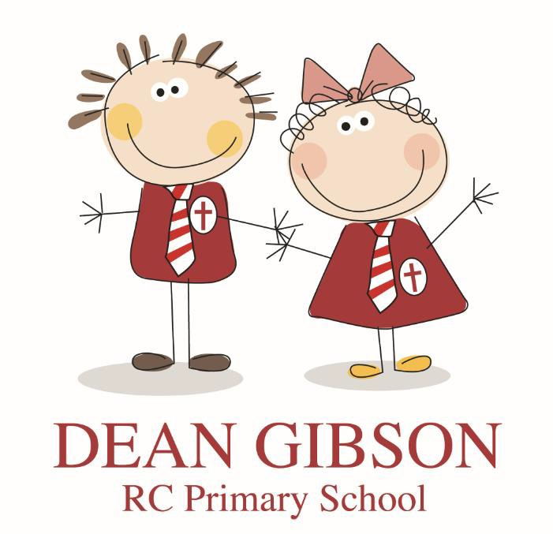

DEAN GIBSON CATHOLIC PRIMARY SCHOOL

STATUTORY FRAMEWORK SUMMARY FOR THE EARLY YEARS FOUNDATION STAGE

TAKEN FROM THE D.F.E. PUBLICATION SEPTEMBER 2021

This document is written in the light of the school’s mission statement.

This document sets the standards for all early year providers. Early Years Foundation Stage (E.Y.F.S) seeks to provide:

- Quality and Consistency
- A secure foundation.
- Partnership working.
- Equality and opportunity.

The E.Y.F.S specifies areas for learning, development and welfare. This includes:
- Areas for learning and development.
- Goals for pupils to work towards.
- Assessment arrangements.
- Requirements for reporting to carers/ parents.

SECTION 1: THE LEARNING AND DEVELPOMENT REQUIREMENTS
The E.Y.F.S Learning and development and the educational program comprise of:
- The seven areas for learning and development.
- The early learning goals.
- The assessment requirements.

AREAS FOR LEARNING AND DEVELPOMENT:
- Communication and Language.

- Physical Development.
- Personal, social, and emotional development.

Providers must also support children in 4 specific areas, through which the three prime areas are strengthened and applied. These are:
- Literacy.
- Mathematics.
- Understanding this world.
- Expressive arts and design.

Practitioners must consider the individual needs, interests and stage of each child. They must use this information to plan challenging and enjoyable experiences for each child in all areas of learning.

Practitioners must consider if a child has need of specialist help, e.g. requiring specialist help for:
- Disability.
- English as a second language.
- Practitioners must link with the families in orders to access relevant services from other agencies as appropriate.

Each area of learning must be implemented through planned purposeful play and through a mixture of adult led and child initiated activity. In planning and guiding children’s activities, practitioners must reflect on the different ways children learn and reflect these in practice. For example:
- Playing and exploring.
- Active learning
- Creating and thinking critically.

Each child should be assigned a key person to overlook the child’s welfare and safety and individual needs. Parents and carers will be told who the key person is.

EARLY LEARNING GOALS

- Listening, Attention and Understanding
- Speaking.
- Physical Development – Gross Motor Skills and Fine Motor Skills
- Personal, Social and Emotional Development – Self Regulation, Managing Self and Building Relationships

THE SPECIFIC AREAS LITERACY:

Literacy

ELG: Comprehension
Children at the expected level of development will:
- Demonstrate understanding of what has been read to them by retelling stories and narratives using their own words and recently introduced vocabulary;
- Anticipate – where appropriate – key events in stories;
- Use and understand recently introduced vocabulary during discussions about stories, non-fiction, rhymes and poems and during role-play.

ELG: Word Reading
Children at the expected level of development will:
- Say a sound for each letter in the alphabet and at least 10 digraphs;
- Read words consistent with their phonic knowledge by sound-blending;
- Read aloud simple sentences and books that are consistent with their phonic knowledge, including some common exception words.

ELG: Writing
Children at the expected level of development will:
- Write recognisable letters, most of which are correctly formed;
- Spell words by identifying sounds in them and representing the sounds with a letter or letters;
- Write simple phrases and sentences that can be read by others.

Mathematics

ELG: Number
Children at the expected level of development will:
- Have a deep understanding of number to 10, including the composition of each number;

- Subitise (recognise quantities without counting) up to 5;
- Automatically recall (without reference to rhymes, counting or other aids) number bonds up to 5 (including subtraction facts) and some number bonds to 10, including double facts.

ELG: Numerical Patterns
Children at the expected level of development will:
- Verbally count beyond 20, recognising the pattern of the counting system;
- Compare quantities up to 10 in different contexts, recognising when one quantity is greater than, less than or the same as the other quantity;
- Explore and represent patterns within numbers up to 10, including evens and odds, double facts and how quantities can be distributed equally.

Understanding the World ELG: Past and Present
Children at the expected level of development will:
- Talk about the lives of the people around them and their roles in society;
- Know some similarities and differences between things in the past and now, drawing on their experiences and what has been read in class;
- Understand the past through settings, characters and events encountered in books read in class and storytelling.

ELG: People, Culture and Communities
Children at the expected level of development will:
- Describe their immediate environment using knowledge from observation, discussion, stories, non-fiction texts and maps;
- Know some similarities and differences between different religious and cultural communities in this country, drawing on their experiences and what has been read in class;
- Explain some similarities and differences between life in this country and life in other countries, drawing on knowledge from stories, non-fiction texts and – when appropriate – maps.

ELG: The Natural World
Children at the expected level of development will:
- Explore the natural world around them, making observations and drawing pictures of animals and plants;

- Know some similarities and differences between the natural world around them and contrasting environments, drawing on their experiences and what has been read in class;
- Understand some important processes and changes in the natural world around them, including the seasons and changing states of matter.

Expressive Arts and Design

ELG: Creating with Materials
Children at the expected level of development will:
- Safely use and explore a variety of materials, tools and techniques, experimenting with colour, design, texture, form and function;
- Share their creations, explaining the process they have used;
- Make use of props and materials when role playing characters in narratives and stories.

ELG: Being Imaginative and Expressive
Children at the expected level of development will:
- Invent, adapt and recount narratives and stories with peers and their teacher;
- Sing a range of well-known nursery rhymes and songs;
Perform songs, rhymes, poems and stories with others, and – when appropriate – try to move in time with music.

SECTION 2: ASSESSMENT
- Formative assessment through observation.
- Written records to be kept to a minimum but up to date.

2 year checks:

- There needs to be a progress check at the age of 2 years.
- This enables emerging concerns to be checked, noted and acted upon appropriately.

Practitioners should encourage parents / carers to share information gained from these checks with relevant professionals.

Assessment at the start of the reception year – the Reception Baseline Assessment (RBA)

The Reception Baseline Assessment (RBA) is a short assessment, taken in the first six weeks in which a child starts reception.

Assessment at the end of the EYFS – the Early Years Foundation Stage Profile (EYFSP)

In the final term of the year in which the child reaches age five, and no later than 30 June in that term, the EYFS Profile must be completed for each child.
The Profile provides parents and carers, practitioners and teachers with a well- rounded picture of a child’s knowledge, understanding and abilities, their attainment against expected levels, and their readiness for year 1.
E.YF.S profiles must be reported to the local authority upon request.

SECTION 3: SAFE GUARDING AND WELFARE REQUIREMENTS

CHILD PROTECTION

- Providers must have and implement a policy and procedures to safeguard children.
- These should be in line with the guidance and procedures of the local safeguarding children’s board
- Providers must ensure that all staff are trained and understand safe guarding policy and procedures and have up to date knowledge.
- Staff must be trained in order to identify signs of possible abuse and neglect at the earliest opportunity and respond in a timely and appropriate way.
These may include:
- Significant changes in a child’s behaviour-
- Deterioration in a child’s wellbeing.
- Unexplained bruising, marks or signs of possible abuse or neglect.
- Children’s comments which give rise to concern.
- Any reasons to suspect neglect or abuse outside the setting, e.g., in a child’s home.
- Inappropriate behaviour displayed by other members of staff, or any other person working with the children.

Providers must have regard to the government's statutory guidance ‘Working Together to Safeguard Children’ and to the ‘Prevent duty guidance for England and Wales’. All schools are required to have regard to the government’s ‘Keeping Children Safe in Education’ statutory guidance
The school must notify Ofsted of any allegations. These notifications must be made as soon as possible otherwise an offence against the law is committed.

The School must ensure that suitable people are appointed and are able to fulfil their roles and requirements.

- All staff must undergo a criminal check
- All staff qualifications identify checks and disclosure number must be kept.
- Where the school becomes aware of any cause for disqualification, or that person living in the same house hold as a disqualified person that person must stop working in the school. Ofsted must be notified immediately. In some cases a waiver may be obtained.

Staff must not be under the influence of alcohol, or any other substance. Practitioners taking prescribed drugs must take medical advice to confirm that the medication is unlikely to impair their working with children.

STAFF QUALIFICATIONS, TRAINING, SUPPORT AND SKILLS

The school should ensure that there is:
- Induction training.
- Under take appropriate training in related issues e.g., health and safety, equality and diversity, quality of learning and development.
- Appropriate supervision of staff.
- Providing the opportunities to discuss issues, identify problems and solutions, and receive appropriate training to improve overall effectiveness.

In group settings the manager must hold at least full level 3 qualifications and at least half of the other staff must hold a level 2 qualification.
At least one person holding a pediatric first aid qualification must be on the premises.

STAFF RATIOS

- Staff under the age of 17 years must be supervised at all times.
- For children aged 3 and four in the school environment there should be at least one member of staff for every 13 children.
- For children over 4 years there must be a qualified teacher.
- An infant class must not exceed 30 pupils.
- Where the infant class includes nursery age children statutory requirements must be met.

HEALTH

- The following is required:
- A health procedure for infectious diseases etc. must be in place.
- Parents and carers need to have a copy.
- An administration of medicines policy and procedure should be in place.
- Only healthy snacks and meals should be provided.
- There should be suitable provision for the preparation of meals and snacks.
- There should be a first aid box available.
- No corporal punishment is to be exercised.

MANAGING BEHAVIOUR

No corporal punishment is to be exercised.

HEALTH AND SAFETY

- All surfaces inside and out should be ‘fit for purpose’.
- Health and safety legislation must be complied with.
- No smoking is allowed in or around the premises.
- The premises need to be organised to meet the needs of the children. 2.3m squared for 3 to 5 year olds.
- There should be an adequate toilet and washbasins facilities.
- Risk assessments should be made on a regular basis.
- Vehicles used in outings must be adequately insured.

SPECIAL EDUCATIONAL NEEDS

The school must have in place arrangements to support children with disabilities and educational needs.

INFORMATION AND RECORDS

- Records must be kept and shared with parents / carers and other professionals including the police.
- All records should be treated with confidentiality.
The following information must be made available to parents / carers:

- How the E.YF.S is delivered and how parents /carers can access more information.
- The daily routines and activities provided and how the children can be helped at home.
- How the setting supports children with disabilities and special needs.
- Food and drink provided for the children.
- Details of relevant policies and procedures. (Including complaints).
- Staffing, the child’s key person, their role, and a telephone number for parents/ carers to contact in an emergency.

INFORMATION ABOUT THE PROVIDER

- Name, telephone number and address.
- A daily record of the names of the children, their attendances and the name of their key person.
- The name and telephone number of the person who is in regular unsupervised contact with the child.
- A certificate of registration to be displayed.

CHANGES
All relevant changes need to be notified to Ofsted, for example a change in opening hours, any significant event which is likely to affect the suitability of a member of staff working with the children, any change in the registration number of a company in partnership with the school, or any change in a partnership arrangement.

References
- D.F.E ‘Statutory framework for the early years foundation stage’. Refer to this for further information.
- Health and Safety Policy.
- The Complaints policy and procedure.
- Medicines Policy and procedure,
- Child Protection and Safe Guarding Policy and Procedure.
- Special Needs policy and Procedure.
- Accessibility Policy.
- Records and Reports Policy.
- Equality and Diversity Policy.
- Interviewing and Staff Recruitment Policy and Procedure.
- Communication with Parents and Carers Policy.
- Freedom of Information Policy.
- Assessment, Tracking and Monitoring Procedures.
- Behaviour Policy.
- R. E Policy.

DATES FOR REVIEW - |  | SIGNED BY -
JULY 2016 | AMENDMENTS | NONE
July 2017 | AMENDMENTS
JULY 2018 | AMENDMENTS
JULY 2019 | AMENDMENTS
JULY 2020 | AMENDMENTS

