 | AUTUMN |  |  | SPRING |  |  | SUMMER
Subject Area | Autumn 1st Half  (7 weeks) |  | Autumn 2nd Half  (8 weeks) | Spring 1st half  (6weeks) |  | Spring 2nd Half  (5 weeks) | Summer 1st Half  (6 weeks) | Summer 2nd Half  (7 weeks)
Significant Person | Michael Morpurgo  Neil Armstrong | Isaac Newton |  | Floella Benjamin  Andy Warhol | David Attenborough |  | St George |  | Emmeline Pankhurst
Locality Study/ specialist visitor | Recycling in the Lakes  Kendal Mountain Film Festival | Elf Run  Nursing Home Visit |  | Science Day | River Kent- Kendal Walk  Mass at Church |  | Sports Day |  | Residential Trip
National and whole school events | - 05/09- International Day of Charity  - 09/09- International First Aid Day  - 15/09- International Day of Democracy.  - 16/09-01/10- 1st British Food Fortnight  - 18/09- Jeans for Genes  - 21/09- 21st International Day of Peace the world.  - 21/09- World Gratitude Day  - 23/09- International Day of Sign Languages  - 26/09- European Day of Languages  - 30/09- National Sporting Heritage Day  - All OCT- Black History Month  - All OCT-The Big Draw Festival.  - Oct- International Walk to School Month  - 02/10- World Habitat Day  - 04/10- World Animal Day  - 06/10- World Smile Day  - 10/10- World Homeless Day  - 10/10- World Mental Health Day  - 16/10- World Food Day  - 16-22/10- Recycle Week  - 17/10- International Day for Eradication of Poverty  - 19/10- World Values Day  - 24/10- United Nations Day | - 05/11- Guy Fawkes Night  - 6th -12/11- UK Parliament Week  - 11/11- Remembrance Day  - 12-19/11 Inter Faith Week  - 13/11 – 17th Anti-Bullying Week  - 13/11- Kindness Day UK  - 14/11- World Diabetes Day  - 16/11- International Day of Tolerance  - 17/11 - Children In Need  - 19/11 – 25th Road Safety Week  - 02/12- International Day for Abolition of Slavery  - 2– 8/12- National Grief Awareness Week  - 03/12- International Day of People with Disabilities  - 07/12- Christmas Jumper Day  - 10/12- Human Rights Day  - 18/12- International Migrants Day |  | - 04/01- World Braille Day  - 15/01- Martin Luther King Day  - 21/01- World Religion Day  - 27/01- Holocaust Memorial Day  - 29/01- RNLI SOS Day  - 01/02- Time to Talk Day  - 5-11/02- Children’s Mental Health Week  - 06/02- Safer Internet Day  - 14-20/02- Random Acts of Kindness Week  - 21/02- International Mother Language Day | - 03/03- World Wildlife Day  - 08/03- International Women’s Day  - 16/03- Young Carers Action Day  - 21/03- International Day for Elimination of Racial Discrimination  - 02/03- World Water Day  - All April- Stress Awareness Month  - 02/04- World Autism Awareness Day  - 07/04- World Health Day  - 15/04- World Art Day  - 22/04- Earth Day |  | - All May- Local and Community History Month  - 6-12/05- Deaf Awareness Week  - 13-19/05- Mental Health Awareness Week  - 15/05- International Day of Families  - 17/05- Endangered Species Day  - 20/05- World Bee Day  - 20-25/05-Walk to School Week  - 21/05- World Day for Cultural Diversity  - 28/05- World Hunger Day  - 01-07/06- Volunteers’ Week  - 05/06- World Environment Day  - 08/06- World Ocean Day  - 10-14/06- Healthy Eating Week  - 16-22/06- World Refugee Week  - 21/06- World Music Day |  | - 11/07- World Population Day  - 12/07- Malala Yousafzai’s Birthday  - 14/07- Emmeline Pankhurst Day  - 18/07- Nelson Mandela International Day  - 30/07- International Day of Friendship
Quality Texts  Take one book | 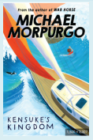 | 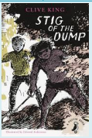 |  | 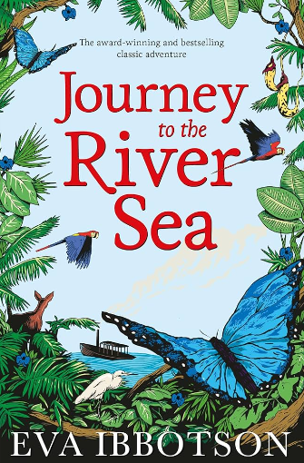 |  |  | 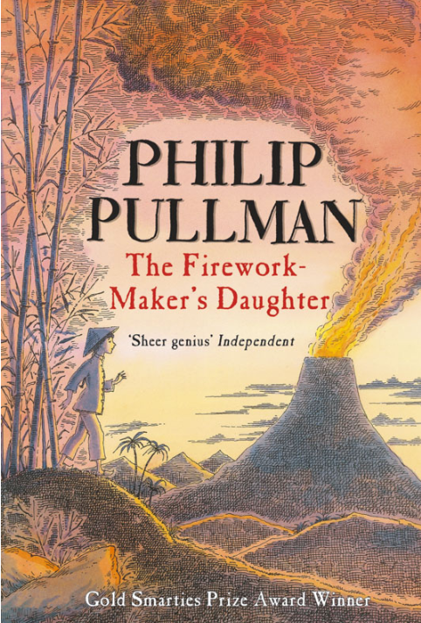 |  | 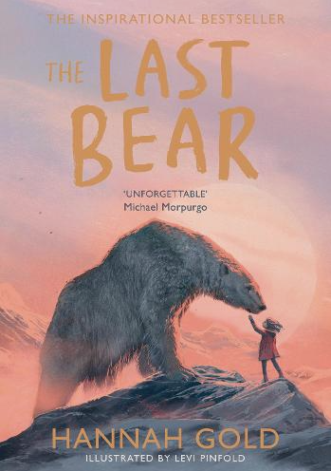
Literacy | Narrative  Non-chronological reports,  Discussion/Balanced argument. | Poetry  Persuasive writing. |  | Narrative  Letters/postcards. | Poetry  Journalist report, Recounts. |  | Narrative  Explanations. |  | Poetry  Instructions.
Mathematics | Place Value,  Addition & Subtraction | Multiplication and Division  Fractions |  | Multiplication and Division  Fractions | Decimals and percentages  Perimeter and Area, Volume  Statistics |  | Algebra  Geometry-angles, shape, position  Measurement |  | Statistics  Number  Calculation
Science | Earth and Space | Forces |  | Separating mixture |  | Energy | Life Cycles |  | Human development
Geography | Investigating world trade |  |  | Looking at North America and Water |  |  | Climate Across the World
History | Stone age to Iron Age |  |  | Ancient Rome |  |  | Quest for Knowledge
Art | Illustration and Narrative Art |  |  | Pattern and Sculpture |  |  | Journeys
D&T | Pulleys and gears |  |  | Framed structures |  |  | Cultures and seasonality’s
RE | Creation | God’s Covenants |  | Inspirational People | Reconciliation |  | Life in the risen Jesus |  | Other Faiths
PSHE  Life to the Full | Created and Loved By God  Religious Understanding  Me, My Body, My Health | Created and Loved By God  Emotional Well Being  Life Cycles |  | Created to Love Others  Religious Understanding  Personal Relationships | Created to Love Others  Keeping Safe |  | Created to Live in Community  Religious Understanding |  | Created to Live in Community  Living in the Wider World
Online Safety  Project Evolve | Self-image and identity | Online relationships |  | Online reputation  Copyright and Ownership | Online bullying  Privacy and Security |  | Managing information online |  | Health wellbeing and lifestyle
Computing | Computing systems and networks – the internet | Creating media – audio production |  | Programming – repetition in shapes |  | Data and information – data logging | Creating media – photo editing |  | Programming – repetition in games
PE | Netball:  Games | On the Beach:  Dance  Pair Composition:  Gymnastics |  | Co-operation, Communication & Consideration:  Outdoor and Adventurous | Football:  Games  Badminton |  | Heptathlon:  Athletics  Rounders |  | Cricket  Dance Styles:  Dance
Music | Musical structures | Exploring feelings when you play |  | Compose with your friends | Feelings through music |  | Expression and improvisation |  | The show must go on
Spanish | All about me  The Sign of the Cross and Hail Mary | The way we look  Christmas in Spain |  | Eating Out | My World  Easter celebrations |  | In the classroom |  | Our past

