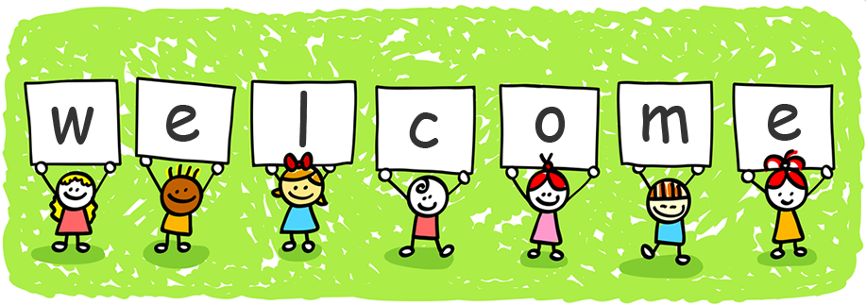

Year 1 Parents Information 2022-2023
Welcome to Year 1! We have a very exciting year ahead with many new skills to develop and topics to explore. Mrs Carter will be with us to support in class each morning and Mrs Joyce will be teaching us on a Tuesday morning.
Curriculum
It is extremely important to have a smooth transition from Foundation Stage to the National Curriculum. Through discussions with Mrs Ritchie, I have a good picture of where the children are in their learning journey and where they need to go next. We have the perfect environment to have play based learning, for those who need it, and challenges for those ready to move on.
Topics this half term
English: Familiar Settings and family stories. Labels, Lists and Signs: Getting and giving information.
Maths: Place value and addition and subtraction.
RE: God’s Great Plan.
Science: Our bodies and our senses.
Art: Portraits.
Geography: What is the geography of where I live?
Life to the Full: Me, My Body, My Health.
Please check out our school website for more detail each term under the class pages tab.

Reading
We will hear the children read in class as much as possible. With this in mind, could you please ensure that your child has their reading record and books with them every day. It is also very important that they read to you at home whenever possible, if not every night. A small positive comment or a short note about any problems in their reading log will be very helpful. Reading books will be changed in class on a Monday and a Friday.

Phonics Screening
We have daily phonics sessions for the children that are tailored to their individual levels. This grouping of the children has been very successful and we see a positive impact in the children’s reading and writing. The phonic sessions start at 9.10 am therefore it is essential that the children are in class and ready to start at that time or they miss out on vital steps in their learning.
The statutory phonics screening check will take place the week commencing Monday 12th June 2023. Please ensure your child is in school this week.
The purpose of the Year 1 phonics check is to confirm whether individual pupils have learnt phonic decoding to an appropriate standard. Pupils who have not reached this standard at the end of Year 1 will receive support from school to ensure they can improve their phonic decoding skills. Pupils will then have the opportunity to retake the screening check at the end of Year 2.
The check will take the form of a ten-page booklet with four words on each page. The check will contain 40 words, which the pupils will read one-to-one to me. Half the words will be real words and the other half will be non-words (pseudo/alien words). Each pseudo word will be accompanied by a picture of an alien. This is used to provide the children with a context for the word they are being asked to decode (naming the imaginary/alien creature).
We will be doing a lot of preparation work in class for the screening test and through homework. Any extra work you can do with your child would be greatly appreciated.
Homework
Homework will be sent out on a Friday. Please ensure your child completes this and returns it to school on the following Wednesday. There will be a mixture of English and Maths homework and occasionally some topic work.
Uniform Reminder
Uniform and bags need to be clearly labeled with names please, including ties!
PE
PE sessions take place on a Tuesday morning with Mrs Joyce. These sessions will sometimes take place outside so please ensure your child has a full outdoor PE kit with everything labelled.
Any concerns or questions about anything here please let me know.
Thank you for your continued support, it is much appreciated.
Mrs Martin and Mrs Carter.

