Dean Gibson Primary School, Kendal
Swifts Spring Newsletter
Curiosity, Diversity, Outdoors
Dear Parents and Carers,
We are writing to share with you an overview of the topics that your child will be learning this half of the Spring term in Swifts Class. At Dean Gibson, we value the important partnership between home and school. Please use the information below to support your child with their learning over the coming weeks.
Reading
Thank you for the effort that you put into reading with your child at home. This is the key to developing skills across the curriculum and the more you can do, the more your child will be able to use these skills in all areas of their learning. Remember to talk to your child about what they are reading as well as listening to them – the type of questions that need an explanation should be combined with fact finding questions.
PE
This half term we are doing Cricket with Adam on Thursday and swimming on Friday. Please ensure your child has a full outdoor PE kit including: wear black or maroon tracksuit bottoms or shorts, a plain white t-shirt, a zipped hooded top/sweatshirt and trainers for Thursday. No football kits or other coloured items are to be worn. For safety reasons children are discouraged from wearing jewellery at school. Though, if they do, we ask that all pupils remove jewellery before PE including earrings, if they cannot be removed then plasters should be provided to cover them up.
Please can all items be named. Also, just a reminder that trainers should not be worn as school shoes.
Outdoor Day
Each term, there will be a day when children will be asked to come in their wellies and outdoor clothes (mud will be expected) and they will spend the day outdoors. Outdoor learning has many benefits, including improving children’s health, engages them with their learning and creates a better connection with nature. Playing teaches children critical life skills, such as teamwork or resilience, but it is also central to children’s enjoyment of childhood. More information will follow.
Snacks
If your child/ren wishes to bring a snack to enjoy at break time, please can you ensure it is of the healthy variety i.e. a piece of fruit, cereal bar etc. they should not be eating crisps or chocolate biscuits as a snack. Children should put this in their trays once they come into class and they should not be choosing from their lunchboxes for snack time.
If you have any questions about the information below, please feel free to make an appointment or call into school and see us.
Thank you for your continuing support,
Mrs Muhvic

Curriculum Overview Spring 1 2024, Swifts
Below are the topics that we are going to be studying this half term.
Subjects | Swifts will be learning about…. | Subjects | Swifts will be learning about….
RE | Jesus, the Teacher  We will be learning about Jesus’s baptism, disciples, Jesus’s teachings and parables. | Science | Plants  In Science we will be exploring what a plant needs to survive, the life cycle of a plant, pollination and seed dispersal and conducting an investigation.
English  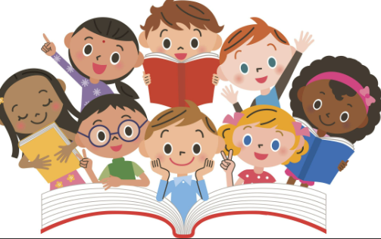 | We are reading ‘The Explorer’ by Katherine Rundell  Through this book we will be writing narrative stories and developing our Persuasive writing and Non-chronological report writing. | Geography | Looking at Tropical Rainforests  We will be learning about the locations of tropical rainforests all over the world, the layers of a tropical rainforest and why the rainforests are important for our planet. We will also be discussing the threat to rainforests and how to protect them.
Maths  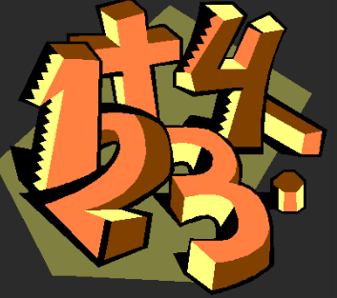 | Multiplication and Division  Fractions  Measurement  We will be multiplying numbers up to 3 digits by 1 digit as well as dividing 2 digit by one digit numbers. Additionally, we will be counting in fractions, learning about unit and non-unit fractions and fractions on a number line. We will also be measuring length and perimeter, mass and capacity. | History | Early Islamic Civilisation  We will be learning about the Early Islamic Empire and where it was situated, the House of Wisdom, achievements in medicine of that time and the important individuals.
Art  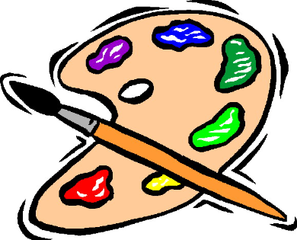 | Watercolour, Tropical Rainforests  In Art will be looking at the works of Henry Rousseau and Abel Rodrigez to inspire us for our watercolour painting, drawing from observation and creating a collage. | Music | Compose using your imagination  We will listen to music and learn new songs which will give us inspiration to compose our own music. Singing and listening are at the heart of each lesson. We will play, improvise and compose using a selection of these notes: C, D, E, F, F♯, G, G♯, A, B.
PE | Cricket  Swimming  We will be joined by Adam on Thursdays for cricket and on Friday we are having our swimming lessons. | HRSE/PSHE | Created to Love Others  Religious Understanding  Personal Relationships  We will be exploring the individual’s relationship with others. Building on the understanding that we have been created out of love and for love. We will explore how we take this calling into our family, friendships and relationships, and look at strategies for developing healthy relationships and keeping safe both online and in our daily lives.
Spanish  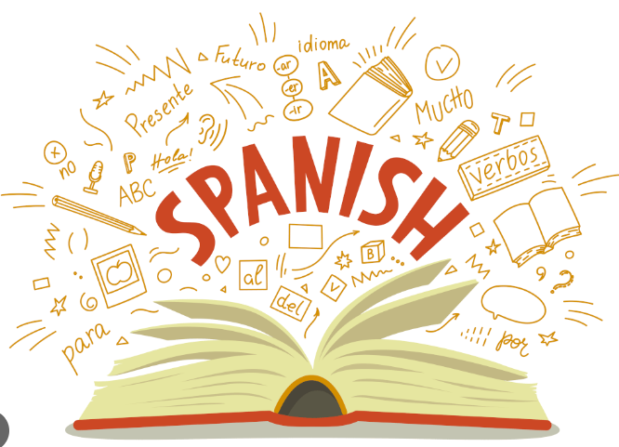 | All About School  Wider World  We will be learning the key vocabulary and phrases about school and school subjects. We will also learn vocabulary related to wider world. | Computing | Programming-Sequencing Sounds  We will be exploring the concept of sequencing through Scratch. We will be introduced to a selection of motion, sound and event blocks and use them to create our own programmes.  The final project will be to make a piano.
DT | Levers and Linkages  We will understand and use lever and linkage mechanisms, distinguish between fixed and loose pivots. We will also know and use technical vocabulary relevant to the project.

Swifts, Spring 1 Homework Grid
Each week you can choose one of these activities to complete for your homework, your books will be sent home each Friday and please can they be returned by the following Wednesday, you can include a note, photo or copy of the piece of work you have completed.
English  Ensure you are reading at home, write a book review of one of the most recent books you have read: what did you like about it? Would you change any parts and why? | Maths  Do an hour of Timetables Rock stars over the week. Spend your coins and draw a picture of your updated character.  Additionally, you cold practise Maths on Top Marks  Maths - Topmarks Search | RE  Choose one of Jesus’s parables and explain in your own words what it teaches us.
Science  Draw a potted plant if you have one at home, or a plant you would like to have. Label its parts, research its life cycle and make notes, drawings or add a photograph. | Geography  Research one of the rainforests of the world and write about the wildlife in it. You could include pictures or drawings of your own. | History  Research one of the Early Islamic Scholars and describe his contributions to modern medicine.
Art  Choose a watercolour that you like, either recreate it in your own way, provide information about it or the artist in any form you prefer. | DT  Make a list of objects in your home and garden that have levers and linkages. | Computing  Explain to your people at home how you can stay safe online, what should you avoid? What would you do if you had any worries about being online?
Spanish  Create a list of your school subjects and the contents of your pencil case in Spanish with English translation. | Music  Listen to your favourite song and think about why you like it, ask the people in your family what their favourite song is and why.  Have a go at writing your own lyrics for a song you know. | PE  Tell someone at home what key skills have we been learning in Cricket with Adam. How do we hold the bat? What must we remember when we are bowling? What makes a good fielder?  Go outdoors and spend time being adventurous.

