Dean Gibson Catholic Primary School
Sparrows Class Spring 2 Newsletter
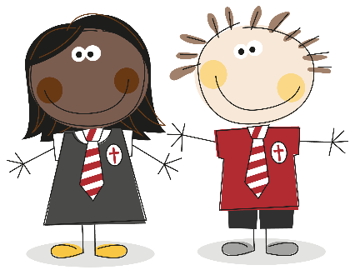
Curiosity, Diversity, Outdoors
Dear Parents and Carers,
We are writing to share with you an overview of the topics that your child will be learning this half of the Spring term in Sparrows Class as well as some other important information.
At Dean Gibson, we value the important partnership between home and school. Please use the information below to support your child with their learning over the coming weeks.
If you have any questions about the information below, please feel free to make an appointment or catch me for a quick chat.
Thank you for your continuing support,
Mrs Martin
Below are the topics that we are going to be studying this half term:
Curriculum Overview Spring 2 Sparrows
Subjects | Sparrows will be learning about…. | Subjects | Sparrows will be learning about….
RE | Desert to Garden  We will be focussing on temptations in the desert, Jesus going to Jerusalem, the Last Supper and the story of Easter. | History | Transport  We will continue to explore changes to transport. This half term we will focus on travelling by car, travelling by train and identifying all the changes we have discussed.
English  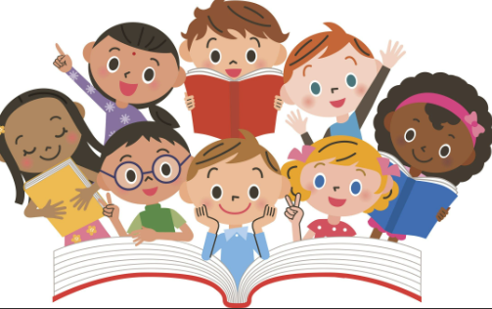 | Postcards  Persuasive Writing  Book – The Man on the Moon | Art/DT | DT – Wheels and axles
Maths | Addition and subtraction within 20  Place value within 50 | Music | Learning to Listen  We will concentrate on learning how to keep a steady beat. We will also clap four-beat rhythms, creating long and short sounds. We will begin to improvise using one, two or three notes, using F, G and A.
Science | Seasonal changes  In Science we will be exploring the weather and the four seasons, including the changes within seasons. Also we will be learning about daytime, night time, how this changes through the seasons and the moon. | PE | PE Coach - Athletics  Our PE session remains on a Thursday morning – please make sure that you have an outdoor PE kit consisting of black bottoms, a white t-shirt and black zip up/hoodie.
Geography | Where we are  In Geography we will continue to explore the countries that make up the UK, what are the capital cities and investigating what urban areas are like. | HRSE/PSHE | Personal Relationships  We will be talking about the special people in our lives and how we treat others.  Online Reputation We will be learning about the need to be careful before sharing anything online and discussing who we can ask if we are unsure about putting something online

Our Class Timetable
A week in the Sparrows looks like this:
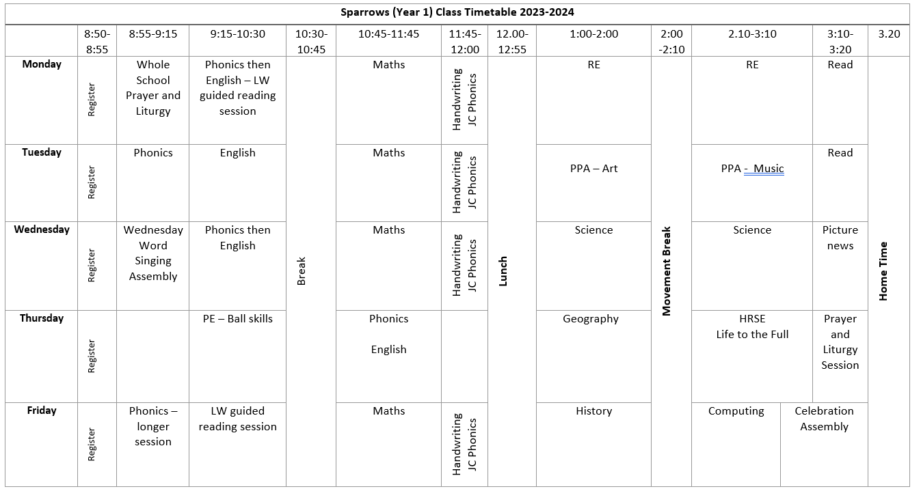

Homework
Choose one of the tasks from the below grid each week and complete, adding a note or a copy of the work that you have done to your homework books. Homework books will be checked each week, please ensure that these are kept in book bags.
Subject | Homework Task | Subject | Homework Task
RE | Share with someone at home the Easter story and create a storyboard to illustrate the events from the Last supper to Jesus rising again. | History | Think about your favourite piece of transport that we have learnt about. Can you get creative and make a model of that type of transport?
English | This half term, we will celebrate World Book Day. Write a review of a book that you have recently enjoyed, why would you recommend it? | Art/DT | You will be looking at wheels in DT. Can you take pictures of things you can find that have wheels?
Maths | Using items at home, what doubles can you make? E.g. using Lego bricks, cars, pasta etc. | Music | Listen to a piece of music. Can you clap along to the beat?
Science | As we complete our work on Seasonal changes, see what signs of spring you can see. Look around you outside for the things we looked at in class, e.g. daffodils, snow drops, buds coming, lighter evenings. Draw a picture of what you find. | Geography | Can you look around you when in and around Kendal – what type of plants and animals can you typically see in an urban area?

PE
Our sessions with Graeme will continue as before half term focusing on athletics on a Thursday morning. Please make sure that you have an outdoor PE kit consisting of black bottoms, a white t-shirt and black zip up/hoodie. Children will also need suitable outdoor footwear.
Outdoor Learning
We will be making the most of outside space and taking our learning outdoors for one day each term, please make sure that your child/ren has weather suitable clothing i.e. wellies and waterproofs, sunhat and suncream on these days. More information and dates to follow.
Reading
Thank you for the effort that you put into reading with your child/ren at home. This is the key to developing skills across the curriculum and the more you can do, the more your child will be able to use these skills in all areas of their learning. Remember to talk to your child about what they are reading as well as listening to them – the type of questions that need an explanation should be combined with fact finding questions. Reading books will continue to be changed in class on a Monday and we will also visit the Library each week to bring home a book to simply enjoy with you at home. Bookbags should be brought to school each day.
Uniform Reminder
Please could you ensure that all uniform including jumpers and ties, PE kits, lunch boxes, water bottles and coats etc. are named.
Snacks
Fruit is provided in class for snacks during morning playtime. If your child/ren wishes to bring a healthy snack i.e. a different piece of fruit, cereal bar etc. to enjoy from home rather than our fruit, please make sure that this is in their bookbags, ready to be stored in their trays once they come into class.

