Review of outcomes in the previous academic year

Pupil premium strategy outcomes
This details the impact that our pupil premium activity had on pupils in the 2021 to 2022 academic year.
Pupil Premium Children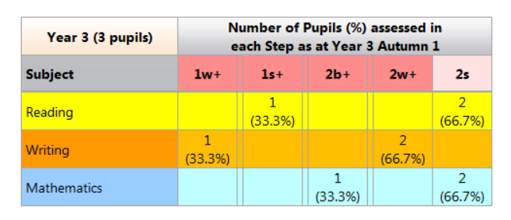N.B Year 3 data shows the attainment for the cohort when they were in Year 2.
In Reading 67% of the children reached expected or greater depth.
In Writing 0% of the children expected standard.
In Maths 67% of the children reached the expected standard.

Compared to the Non-Pupil Premium Children
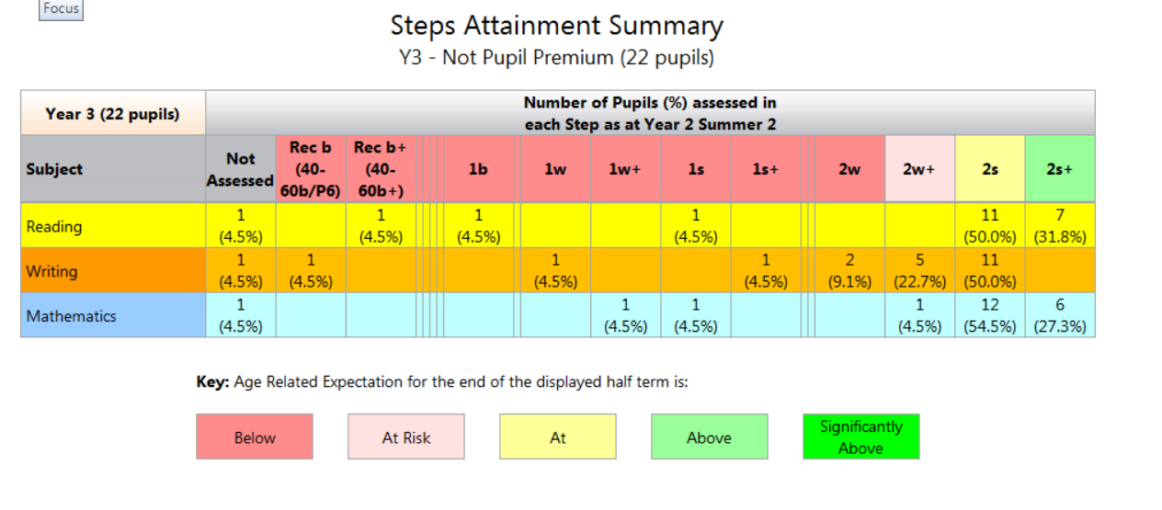

In Reading 82% of the children reached expected or greater depth.
In Writing 50% of the children expected standard.
In Maths 82% of the children reached the expected standard or greater depth.
Year 6 cohort.
In Reading 33% WTS
33% of the children reached expected standard.
33% of the children reached Greater Depth
In Writing 66% WTS
33% of the children reached expected standard.
In Maths 33% WTS
66% of the children reached the expected standard.

