Pupil premium strategy statement – Dean Gibson School

This statement details our school’s use of pupil premium (and recovery premium) funding to help improve the attainment of our disadvantaged pupils.
It outlines our pupil premium strategy, how we intend to spend the funding in this academic year and the outcomes for disadvantaged pupils last academic year.

School overview
Detail | Data
Number of pupils in school | 161 + 20 nursery
Proportion (%) of pupil premium eligible pupils | 6%
Academic year/years that our current pupil premium strategy plan covers (3 year plans are recommended) | 2022-23
Date this statement was published | October 2022
Date on which it will be reviewed | July 2023
Statement authorised by | Sarah Tansey
Pupil premium lead | Clare Ritchie
Governor / Trustee lead

Funding overview
Detail | Amount
Pupil premium funding allocation this academic year | £1385 x 14  PP plus £2410 x 4  Total: £29030
Recovery premium funding allocation this academic year | £0
Pupil premium (and recovery premium*) funding carried forward from previous years | £0
Total budget for this academic year | £29030

Part A: Pupil premium strategy plan

Statement of intent
Our aim at Dean Gibson Primary School is to provide all students with the opportunity to achieve their full potential. We want our children to be knowledgeable of the world around them and to develop the skills and values to be successful and make positive contribution to society. We have high aspirations and ambitions for all of our children and believe that no child should be left behind.
We employ strategies and interventions to remove barriers which can be caused by personal circumstances or learning gaps. We promote all students having full access to the rich extra-curricular provision on offer at Dean Gibson Primary School. This ensures we develop well-rounded individuals who achieve their ambitions and flourish in life.
Common barriers to learning for disadvantaged pupils may include:
- ➢ less support at home
- ➢ weak language and communication skills
- ➢ lack of confidence
- ➢ more frequent behaviour difficulties
- ➢ attendance and punctuality issues
There may also be complex family situations that prevent children from flourishing. The challenges are varied and there is no “one size fits all” plan for support.
Our ultimate objectives are:
➢ eliminate the attainment gap between disadvantaged and non-disadvantaged pupils at Dean Gibson Primary School
➢ for all disadvantaged pupils in school to meet or exceed nationally expected progress rates
➢ for all disadvantaged pupils to access to the rich extra-curricular provision on offer and be well-rounded individuals who achieve their ambitions and flourish in life
We aim to do this through:
➢ frequent monitoring of qualitative and quantitative data to ensure accurate and timely identification of pupils in need of support
➢ ensuring that teaching and learning opportunities meet the needs of all the pupils and that where pupils have specific needs that these are addressed through high quality, evidence-based interventions led by appropriately trained staff
➢ ensuring all vulnerable learners are ready to learn through access to a breakfast club, equipment and uniform provision.
➢ close monitoring of attendance at extracurricular provisions along with promotion and support to increase the attendance of vulnerable learners
➢ ensuring that vulnerable learners have access to high quality pastoral and mental health support
➢ When making provision for socially disadvantaged pupils, we recognise that not all pupils who receive free school meals will be socially disadvantaged and that not all pupils who are socially disadvantaged are registered or qualify for free school meals. We reserve the right to allocate Pupil Premium funding to support any pupil or groups of pupils the school has legitimately identified as being socially disadvantaged.
➢ Pupil Premium funding will be allocated following a needs analysis which will identify priority classes, groups or individuals. Limited funding and resources means that not all children receiving free school meals will be in receipt of Pupil Premium interventions at one time.
Achieving these objectives:
The range of provisions available at Dean Gibson Primary School include but are not limited to:
➢ frequent monitoring of progress and needs from the Head Teacher, Deputy Head Teacher/Pupil Premium Lead and the SENCo
➢ literacy and numeracy support which includes in class support and small group withdrawal
➢ running a breakfast club to ensure vulnerable learners are prepared for the day
➢ tracking and monitoring attendance to provide intervention and support where a need is identified
➢ allocating high quality teaching assistants to support wellbeing.

Challenges
This details the key challenges to achievement that we have identified among our disadvantaged pupils.
Challenge number | Detail of challenge
1 | Social use of language and conversational skills
2 | Acquisition of writing skills and stamina for writing
3 | Emotional well-being and roles within their family as young carers
4 | Attendance and late arrival leading to loss of learning
5 | Staff awareness of Pupil Premium children and strategies for success.

Intended outcomes
This explains the outcomes we are aiming for by the end of our current strategy plan, and how we will measure whether they have been achieved.
Intended outcome | Success criteria
Children in receipt of pupil premium achieve their expected target in line with their peers with similar starting points. | 80%+ make expected or better than expected, or better than expected progress in reading, writing and mathematics.
Pupils emotional and mental health needs are met and receive the necessary support when required. | All pupils feel safe and happy at school, maintaining a positive attitude towards their learning, and build positive relationships with their peers and staff members.
Parents are actively engaged in their child’s learning and promote a positive attitude towards education | Parental communication is effective, especially during home learning periods.  Parents attend parents’ evenings. Parents support homework.  Pupil attendance is in-line with peers.
All pupils have access and equal opportunities to participate in extra-curricular activity. | All pupils in receipt of pupil premium are able to participate in chosen extra-curricular activity.

Activity in this academic year
This details how we intend to spend our pupil premium (and recovery premium) funding this academic year to address the challenges listed above.

Teaching (for example, CPD, recruitment and retention)
Budgeted cost: £11,000
Activity | Evidence that supports this approach | Challenge number(s) addressed
Use of TAs to provide targeted intervention for pupils whose prior attainment indicates the need for them to make accelerated progress to reach appropriate ARE. | Sutton Trust’s 2011 report revealed that the effects of high-quality teaching are especially significant for pupils from disadvantaged backgrounds. This has been highly successful in the past. Use of intervention plans ensured that children made significantly better than average progress in reading, and mathematics. Use of TAs enabled higher adult to pupil ratios within classes to support teaching and learning. | 1,3  TA 15 hours a week
Use of Study Ladder, Times Table Rock Stars and IDL | Has worked well for the last 2 years and is also supported by evidence from Education Endowment Foundation (EEF). Effective use and outcomes of TTRS reported by other schools. | 2,4  £600 for IDL  £157.68 for Timetables Rock Stars

Targeted academic support (for example, tutoring, one-to-one support, structured interventions)
Budgeted cost: £7,000
Activity | Evidence that supports this approach | Challenge number(s) addressed
1:1 and small group TA led provision based on teacher directed activities following half- termly progress review | Some children would benefit from targeted support to catch up and ‘close the gap’. This worked well in addressing gaps in progress with  1:1 children in the past. | 1,2,3,4  TA support  TA 12.5 hours a week
1:1 focused sessions with a TA to ensure that identified gaps in knowledge/skills are filled | The use of the initial ‘catch up’ funding has shown that some children benefit from being taught in a different environment and by a different adult for specific interventions in our school. | 1,2,3,4

Wider strategies (for example, related to attendance, behaviour, wellbeing)
Budgeted cost: £11,000
Activity | Evidence that supports this approach |  | Challenge number(s) addressed
No charge for children in receipt of pupil premium for extra-curricular activities and Breakfast Club offered to ensure breakfast has been given to each child at the start of the day. | EEF research indicates improved outcomes have been identified in English, mathematics and science learning. On average greater effects have been identified for younger learners. Widespread evidence on positive impact on self-esteem. | 1,4,5  Piano lessons £546  Taxi £612  Breakfast Club £665  Uniform £42  Milk £50  School trips £600
Ensure children have access to experienced emotional literacy support Assistant. (PW) | Research (See study by Bowerman & Davies, Child and Educational Psychologists, Cheshire West and Chester, Spring 2018) suggests positive outcomes for LAC children in relation to access to ELSA. | 1,4,5  12.5 hours a week  £7425
Educational Psychologist assessments to expedite the process to support EHCP applications |  | £300 per child  £1850

Total budgeted cost: £ 29,000

Review of outcomes in the previous academic year

Pupil premium strategy outcomes
This details the impact that our pupil premium activity had on pupils in the 2021 to 2022 academic year.
Pupil Premium Children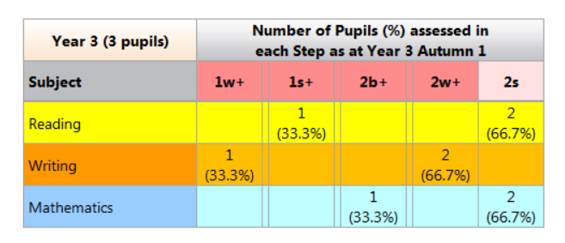N.B Year 3 data shows the attainment for the cohort when they were in Year 2.
In Reading 67% of the children reached expected or greater depth.
In Writing 0% of the children expected standard.
In Maths 67% of the children reached the expected standard.

Compared to the Non-Pupil Premium Children
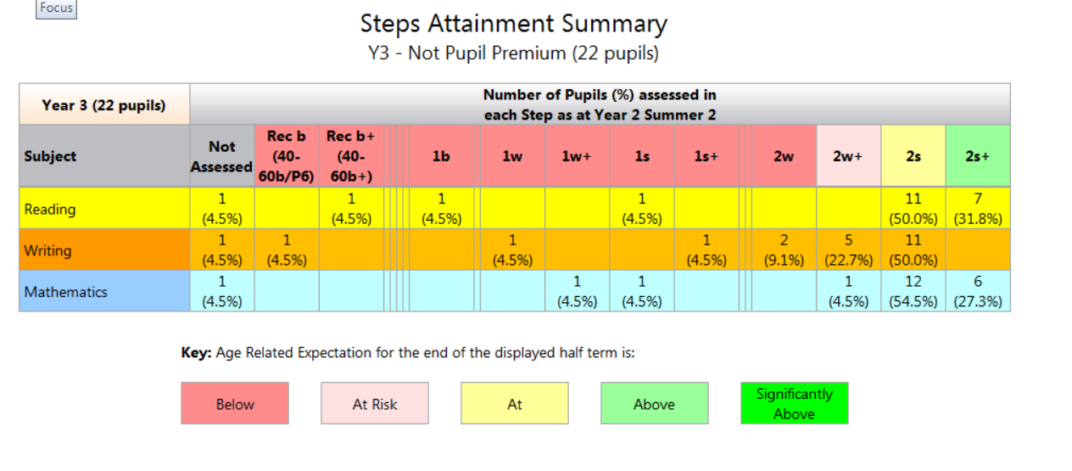

In Reading 82% of the children reached expected or greater depth.
In Writing 50% of the children expected standard.
In Maths 82% of the children reached the expected standard or greater depth.
Year 6 cohort.
In Reading 33% WTS
33% of the children reached expected standard.
33% of the children reached Greater Depth
In Writing 66% WTS
33% of the children reached expected standard.
In Maths 33% WTS
66% of the children reached the expected standard.

