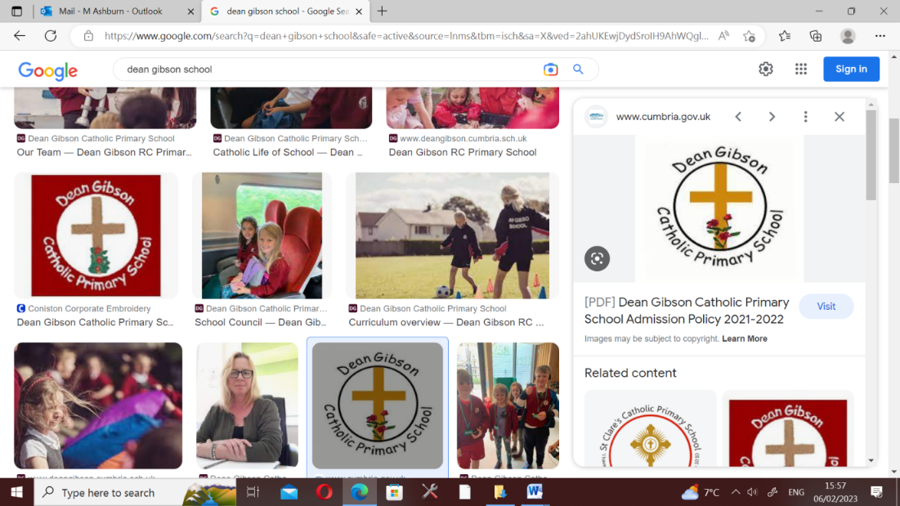

**18th September 2023**

**Year 6 Parent Information**

Dear Parents,

I would like to welcome you and your child to Year Six. The purpose of this letter is to share the key information about your child’s new class; their final year at Dean Gibson!

**Mind-set, positivity and happiness**

A positive approach to learning and a positive mind-set is crucial. We aim to develop this further in Year 6. Happiness and positivity are crucial building blocks to successful learning.

**Homework**

The homework system in school has been revamped. To make things a little more creative, I have put together a list of fifteen activities across a range of subject areas. Your child will choose one homework activity to do each week up until the final week of term. Then during the final week before Christmas, your child will present their homework activities to the class. To evidence what they have done, you may take photographs and make a folder for the homework to go in. Models or artwork may also be brought in, so the children can show of their creations. The autumn homework grid will come out this Friday. Extra SATs revision will be given out throughout the year.

**Year 6 Responsibilities**

In Year 6, there are more jobs and responsibilities given to the children around school. Jobs such as librarians, lunch time helpers and assembly monitors are all jobs which Year 6 have the opportunity to help with. These jobs will be swapped half-termly.

**SATs**

As you will be aware, your child will take the national Year 6 SATs tests in May. This year, the SATs tests will take place on week commencing Monday 13th May 2024. Your child will be tested in SPAG (Spelling, Punctuation & Grammar), Maths, Reading and Writing (teacher assessment). CGP revision guides and workbooks are very helpful and can be bought at any reputable book shop to help your child prepare.

**School Council**

In Year 6, three children are selected to represent Year 6, Year 1 and EYFS on the school council. Children who wish to participate, prepare a speech or presentation of no longer than five minutes, explaining why they would make a good school council member. During the presentation, they will put forward practical ideas for how we could improve school life. Their peers and the younger children will then vote for who they think will make the best councillor. Hustings for the school council positions will be coming up in the next couple of weeks, so watch out for the letter!

**Teaching Assistants**

We have Mrs Dixon working with us in Year 6. She will support the children in their learning and is very experienced.

**Reading**

The children are given a little more freedom with their reading books in Year 6. Children are allowed to bring in a book from home, choose one from the class reading corner or school library. Whichever option, each child must have an age appropriate reading book at all times. Mrs Dixon and I will check in with the children to ensure they have a book. We ask that parents oversee this too and ensure regular reading takes place at home.

**Mobile Phones**

If your child is walking to and from school unaccompanied or going somewhere after school, then they may bring in their mobile phone, which will be kept in the school safe. On arrival to school, please ensure your child puts their phone into the safe. Children are not expected to bring in a mobile phone unless there is good reason to do so.

**Residential**

At the end of June/beginning of July, there will be a two day residential for Year 6 children. This will be an outdoor and adventurous based visit in the Lake District. More details will follow as the year progresses.

**Rewards**

We use dojo points as a reward for good behaviour in year 6. Prizes will be given from the prize-box when thirty dojo points have been earned. Children get rewarded for positive behaviour including: being helpful, producing good pieces of work, tidying up, politeness or working particularly hard. In addition to this, gold star stickers will be awarded for outstanding pieces of work and behaviour.

Each week children receive the *good values*, *curiosity*, *caring* and *resilience* awards in the Friday celebration assembly. All parents, family members and friends are welcome to attend.

**Extra Work and Websites**

There are many good websites out there to supplement the word undertaken in class these include:

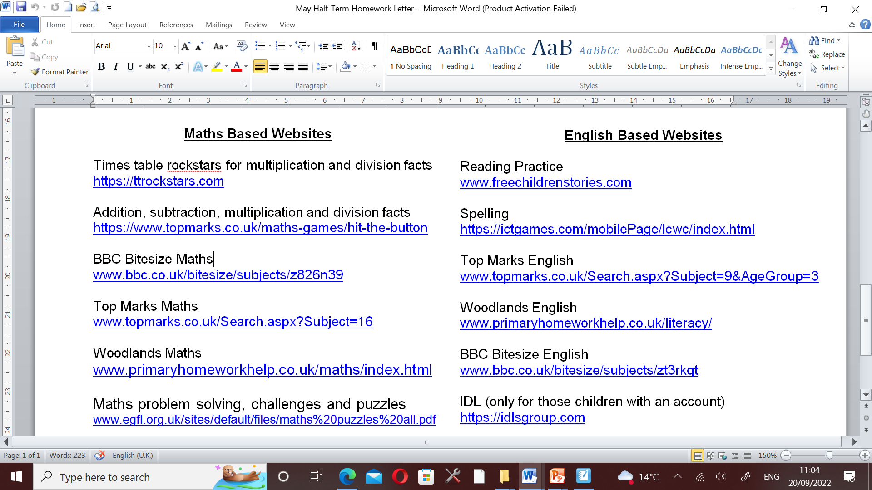

Key Stage 2/Year 6 CGP workbooks for SPAG, Maths and Reading, as well as the revision guides, are also very helpful in helping your child prepare for the SATs tests.

**Physical Education**

Physical Education for Year 6 will take place on Thursday afternoons. Please ensure your child has their indoor and outdoor PE kit in school for this.

**KKS & QKS Open Evenings**

Open evenings for Year 6 children and parents at Kirkbie Kendal and Queen Katherine Schools take place this week. It is definitely worth looking around both schools, as choosing the correct Secondary setting for your child is an important decision. Kirkbie Kendal’s open evening is on Tuesday 19th September from 5-8pm, while the Queen Katherine open evening is on Wednesday 20th September from 5:30-8:15pm.

Thank you for attending and if you have any questions, please do not hesitate to contact me.

Best Wishes



Mr Ashburn

Year 6 teacher