Dean Gibson Catholic Primary School
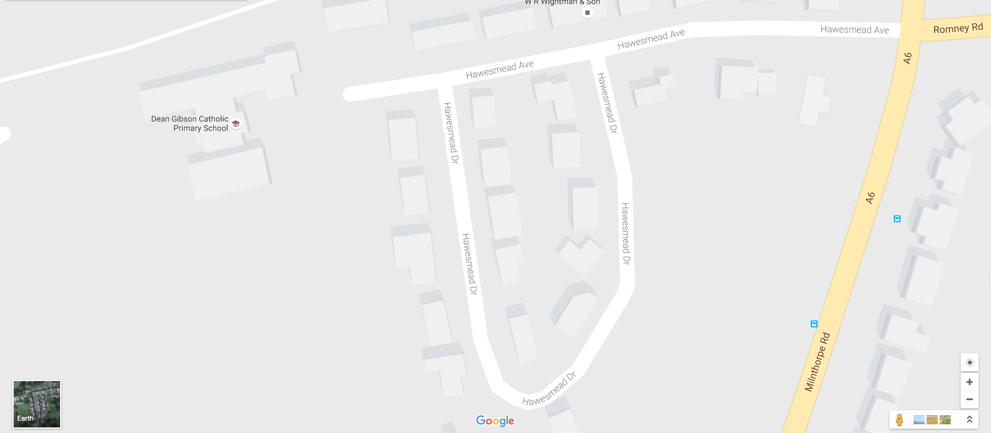
One Way System for Dropping Off and Picking Up
Please also note the School car park is a STAFF ONLY car park. This is also the only vehicle access to the School so the entrance must not be blocked or parked in front of. Thank you.

