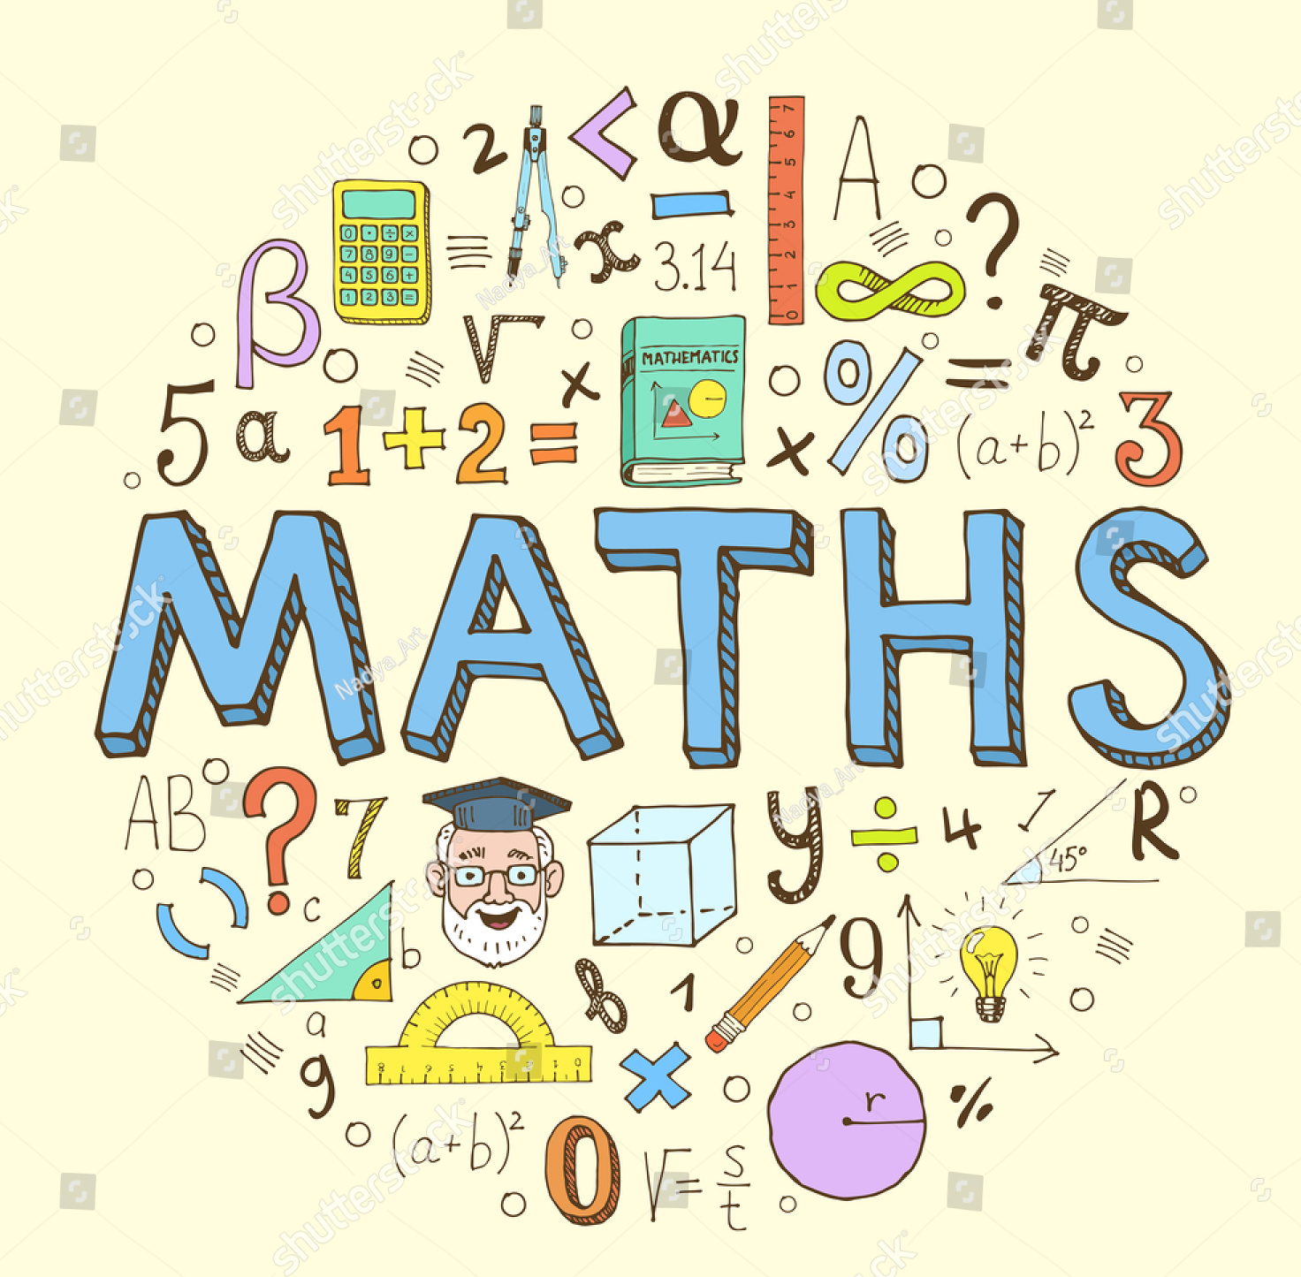
Mathematics
Policy

At Dean Gibson Catholic Primary School our children are Mathematicians

Our Mathematics Vision
At Dean Gibson Catholic Primary School, we take a mastery approach to the teaching and learning of Mathematics. Essentially, our ethos is that all children can be successful in the study of Mathematics. Mathematics is for everyone! We teach the skills to ensure our children are resilient and curious learners who become life-long Mathematicians. We aim to deliver an inspiring and engaging Mathematics curriculum through White Rose Mathematics, the outdoors and high-quality teaching.
The White Rose Mathematics approach enables children to be numerate, fluent, creative, independent, curious, enquiring and confident. Children should not be afraid to make mistakes and should fully embrace the fact that mistakes are part of learning! A mastery curriculum promotes a deep, long-term, secure and adaptable understanding of the subject, so that children become fluent in calculations; possess a growing confidence to reason mathematically and hone their problem-solving skills.

The drivers of our curriculum are: Outdoors, Diversity and Curiosity.
Aims of our school
-To develop a love of Mathematics in children from EYFS through to Year 6.
- Ensure that children become fluent in the fundamentals of mathematics, including through varied and frequent practice with increasingly complex problems over time, so that pupils develop conceptual understanding and the ability to recall and apply knowledge rapidly and accurately.
- Ensure children can reason mathematically by following a line of enquiry and justification or proof using mathematical language.
- Children can solve problems by applying their mathematics to a variety of routine and non-routine problems with increasing sophistication, including breaking down problems into a series of simpler steps and persevering in seeking solutions.
-Children understand that Mathematics is relevant to everyday living and a lifelong skill, by solving problems that are set in a real life context.
-To develop critical thinking and the confidence to question ideas in order to deepen their understanding.
-To use personal qualities of curiosity, creativity and resilience in Mathematics.
What do our Mathematics lessons look like?
We teach Mathematics through a mastery approach. As a result, in lessons you will see whole class teaching in line with the principles outlined in the ‘Essence of teaching for Mastery’ document published by the NCETM. The Essence of Mathematics Teaching for Mastery | NCETM
Lessons will be vibrant and enjoyable, with teachers using a range of resources including models and images to develop children’s mathematics within a concrete, pictorial, abstract approach. Children will be highly engaged and challenged through discussion and mathematical talk, utilising skills of reasoning and explanation alongside accurate use of mathematical vocabulary, which is explicitly taught within lessons.
Assessment
Teachers continually assess children’s needs and developments and alter their planning and teaching accordingly. Teachers engage children in assessing their own work through the use of success criteria and formative assessment so children know what their next steps in learning are. Teachers also use summative assessments to assess children termly. We use assessment resources from Test Base and past SATs papers to identify areas for development for individual pupils. The results of these assessment procedures are used to inform teachers planning and track the progress of pupils. Progress is reported to parents at parents’ evenings, through termly progress reports, in the end of year report and also through ongoing dialogue between home and school.
The role of Subject Leader
- To promote a high profile for the subject and to ensure that Mathematics has a positive effect on all pupils.
- To analyse termly assessments and report standards to HT and governors.
- To carry out regular monitoring with feedback and support given and report outcomes to the governors and HT.
- To ensure a full range of relevant and effective resources are available to enhance and support learning.
- To be a positive role-model for the teaching of Mathematics in school, assisting and advising in the teaching of Mathematics.
- To liaise with external providers such as the Mathematics Hub to improve the quality of Education and ensure that staff have the essential training, resources and knowledge to teach the Mathematics curriculum.
- To enrich the Mathematics curriculum through additional opportunities and events.

What does a Mathematician need in EYFS?
- Access to a wide range of appropriate resources.
- Access to concrete objects to use mathematically.
- Independent time given to complete tasks.
- Mathematics Vocabulary.
- Talk Time around Mathematics topics.
- Experience practical Mathematics.
- Children in Nursery have a short daily Mathematics teaching session, during which time they begin to develop their understanding of simple mathematical concepts such as counting to 20, maintaining 1 to 1 correspondence, simple addition and subtraction facts, to recognise and describe simple 2d and 3d shapes. Children are taught these concepts using physical resources, pictorial resources, songs, games and role-play.
What does a Mathematician need in KS1?
- Access to materials, tools and resources to assist with practical Mathematics.
- Mathematics vocabulary to help with their topic-specific vocabulary.
- Fluency in number facts and time tables to help with Mathematics problems and reasoning.
- Concrete – children have the opportunity to use concrete objects and manipulatives to help them understand and explain what they are doing.
- Pictorial – children then build on this concrete approach by using these pictorial representations, which can then be used to reason and solve problems.
- Abstract – with the foundations firmly laid by using the concrete and pictorial methods the children can move onto an abstract approach using numbers and key concepts with confidence.

What does a Mathematician need in KS2?
- Access to materials, tools and resources to assist with practical Mathematics.
- Have access the Times Table Rockstars and other websites
- Mathematics vocabulary to help with their topic-specific vocabulary.
- Fluency in number facts and time tables to help with Mathematics problems and reasoning.
- High quality resources are used in conjunction with White Rose to support, stretch and challenge all children within the classroom. In addition, the school’s calculation policy is used to ensure a coherent approach to teaching the operations across our school.
- Concrete – children have the opportunity to use concrete objects and manipulatives to help them understand and explain what they are doing.
- Pictorial – children then build on this concrete approach by using these pictorial representations, which can then be used to reason and solve problems.
- Abstract – with the foundations firmly laid by using the concrete and pictorial methods the children can move onto an abstract approach using numbers and key concepts with confidence.
Inclusion
- All children at our school will have the opportunity to work with a range of equipment, concrete materials (number lines, counters, arrays etc) to help with understanding.
- Adaptive teaching is utilised to meet individual needs and provide appropriate levels of challenge for all pupils.
- Children who would benefit will have additional intervention and support or pre-teach with Mathematics.
- The expectation is that the majority of pupils will move through the programmes of study at broadly the same pace. However, decisions about when to progress will always be based on the security of pupils’ understanding and their readiness to progress to the next stage. Pupils who grasp concepts rapidly will be challenged through opportunities to further deepen their understanding. Those who are not sufficiently fluent with earlier material should consolidate their understanding, including through additional practice, before moving on.
Enrichment
At Dean Gibson Primary School, we enrich the Mathematics curriculum through activities such as:
- Mathematics themed days or week.
- Outdoor learning in Mathematics.
- STEM Week.
- Educational Visits.
- Links with KKS, QKS and Kendal College.
- Cross-curricular links.
We will review this policy annually.
Review date : January 2025

