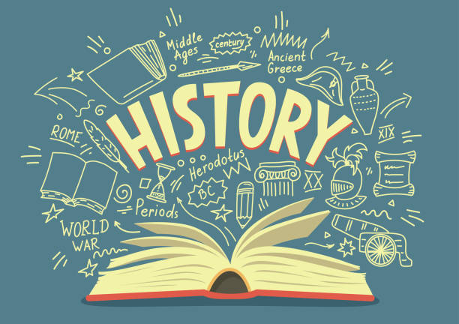
We are Historians
Intent
To ensure that our children leave Dean Gibson with the building blocks to become curious, knowledgeable and skilful historians.
Our history Curriculum consists of termly topics from Nursery and Reception through to Year 6. We aim to deliver a high-quality history education that encourages children to become passionate historians. In history, when a child leaves Dean Gibson we would like them to be curious and knowledgeable about Ancient, Medieval, Early Modern and Modern time periods across parts of the world. During their time at Dean Gibson, we would like our children to become rich in skills and knowledge for all aspects of the Primary History curriculum and understand how a diverse range of people in the past have shaped the world in which we live today. We would like to see children develop an understanding of chronology and gain an understanding of our locality, ourselves and others by having a good insight into the past. Upon leaving Dean Gibson we would like children to take the foundations with them to secondary school and build on their pre-existing knowledge of this subject to become budding historians.

Enrichment
Historians/Figures in History. | Examples of how we enrich our curriculum | Whole School
Reception | - Walking in our town.  - A visit to church.  - A visit to Kendal Castle  - museum visit.  - Visit from people in our area. | - Use of outdoor areas to do history walks and dramatisations.  - Guided Walk sessions with talks given about the history in our local area.  - Communication and links with other schools using online platform  - Children visit the wall memorial to pay respects during remembrance.  - History days- ‘Step back into the Past.’  - Talks with local historians and those with extensive knowledge in this subject.
School grounds, Kendal.
King Charles III
Queen Elizabeth II
Other Kings and Queens of the past

Year 1 | - Walk around Kendal  - Haverthwaite railway, steamer on Lake Windermere and Beatrix Potter World. (History of transport)  - Homes through time – Museum of Lakeland life and industry
Kendal, Lake District and a city
The Wright Brothers
Robert and George Stephenson

Year 2/3 & 3/4 | - Guided Walks in the local area  - Kendal Town yards (Local history)  - Kendal Museum – fossils and dinosaur relics  - Lancaster Cathedral/castle  - Guided Walks in the local area.  - Work shops.
Local area, Kendal, and a city
Samuel Pepys
Sacagawea
Michael Collins
The Prophet Muhammad

Year 5 & 6 | - Birdoswald Roman Fort- Hadrian’s wall.  - Ambleside Roman Fort  - Keswick stone circle  - York minster/Jorvik museum  - Visitor linked to topic (explorer)  - Wordsworth’s house  - Church  - Work shops
Local towns, Lake District and a capital city
Roman Emperor Julius Caesar

The Windrush Generation

How Historians are taught at Dean Gibson
This is how it works:
- Lessons provided through cross curricular or discrete lessons
- We will use United Curriculum, a programme that provides resources and lesson plans in line with the National curriculum.
- A lesson each week or double lesson every two weeks.
- Clear progression of skills developed throughout school
- Progression of knowledge developed each year building on prior learning.
- Vocabulary will be taught and will be built upon each year.
- Children will have had the opportunity to use a range of good quality tools and resources and develop competency in using them safely.
- Texts related to their History topic and journey will be clearly displayed and be accessible.
- Children will experience history in their local area and be able to visually see how the area has changed over time. Workshops, trips, visitors and history days that bring topics to life.

This is what adults do:
• Teachers work collaboratively to support each other in the teaching of History, understanding and applying current developments in the subject, and providing direction for the subject in the school.
• Teachers show enthusiasm for the subject.
• Curriculum leader evaluates the strengths and areas for development in the subject and indicate areas for further improvement.
• Create a positive learning environment to encourage discussion and personal opinion
• Ensure a safe working environment.
- Communicate with other schools in different locations, collaborate and share ideas.
• Look for opportunities to use specialists and outside providers when possible or necessary.

This is how we support:
- We teach History to all children, whatever their ability, providing a broad and balanced education to all children.
- Teachers provide learning opportunities matched to the needs of children and adaptive strategies as needed.
- Different technologies are used to allow children with special educational needs to have access and contribute to lessons.
- We will use Enquiry questions for each lesson which will build knowledge towards curriculum milestones. Each year the children will build on their pre-existing knowledge by deepening their disciplinary knowledge.

This is how we challenge:
- We will adapt lessons
- Additional activities to stretch learning or develop skills
- Provide opportunities above and beyond the National Curriculum.

This is how we ensure all children can access the curriculum:
• We aim to introduce new vocabulary to EAL and SEN children before the lesson
• Peer support
• Providing equipment that may support individuals

IMPACTS
This is the impact of the teaching:

- At Dean Gibson Catholic Primary School, the children will refer to themselves as historians.

- Pupils can talk confidently about what they have learnt and give detailed explanations to how and why an event may have happened in the past.

- Children understand the meaning behind past, present and future. They have a good grasp on chronology and significant events and dates from the past.

- Children are able to find differences between then and now and make comparisons between different time periods.

- Children understand history as a construct. They understand the methods of enquiry, and are able to compare primary and secondary sources of evidence, using the evidence to make historical claims.

- Children can talk about physical and human features of the world and debate the human impact on these elements.

- Children know that history extends to the wider world and not just the UK.

- You will see children who are developing their own sense of identity and see the diversity of human experience through studying History.

- Children will leave with a good understanding of historical concepts such as continuity and change, cause and consequence, similarity, difference and significance.

- Children will be able to use a wide range of vocabulary using everyday historical terms.

- What they learn at Dean Gibson can influence their decisions about personal choices, attitudes and values.

- Children demonstrate our gospel values in their learning when reflecting on History and can make links to our faith and other faiths from the past into the present, with a deeper understanding of the catholic faith.

