Religious Education End of Year Expectations
2023 Year – this is subject to change for Year 1 (Sparrows class) and Year 3 (Finches class) as they are moving towards the new curriculum directory
EYFS End of term expectations:
Autumn term:
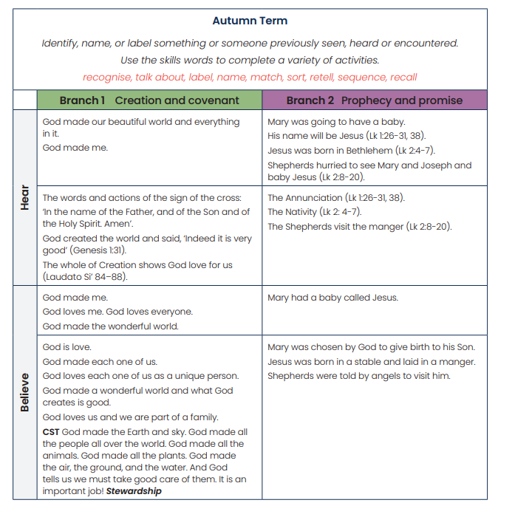
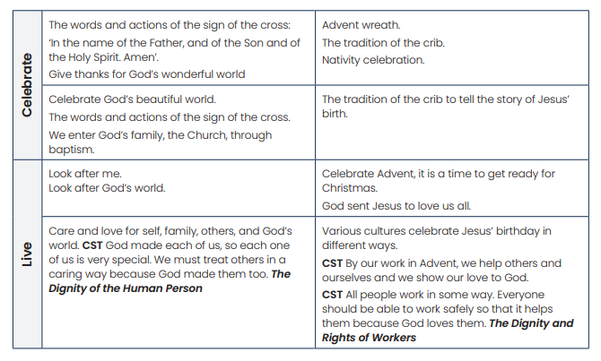

Spring term:
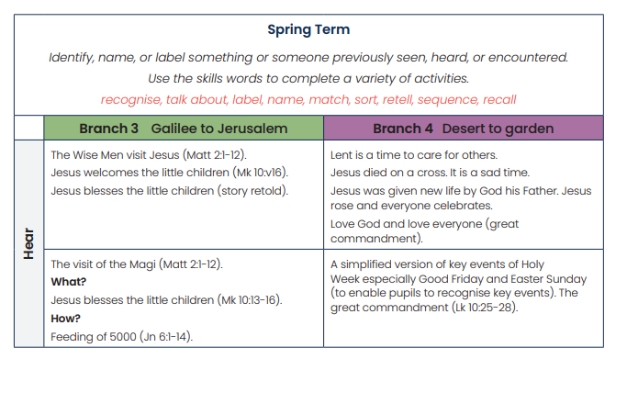
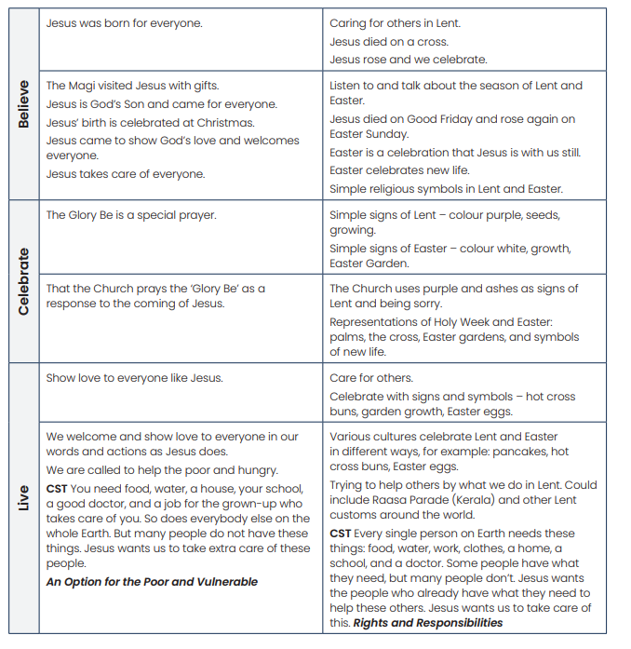
Summer term:
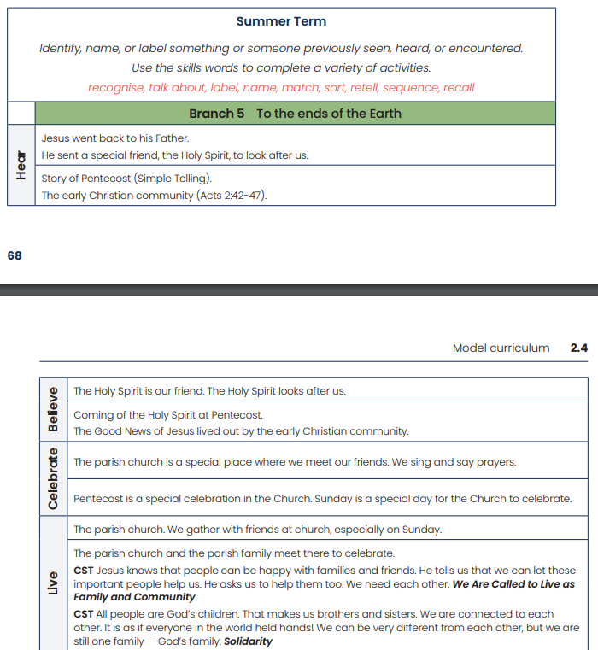
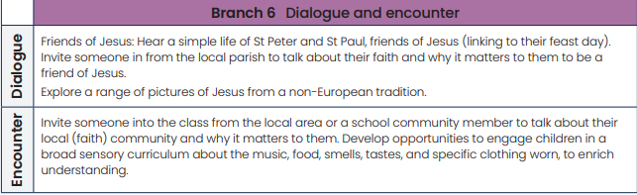

Key Stage One Expectations
End of Year One
Pupils will be able to:
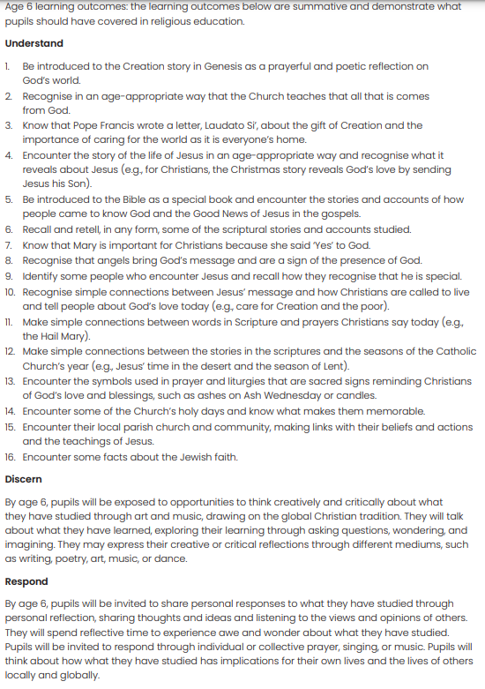
End of Year Two
Pupils will be able to:
End of phase standard | End of year descriptor
KU7 | • Recognise key figures in the history of the People of God
KU8 | • Give clear, simple descriptions of key figures and their relationship with God
KU1/ KU5/ KU6 | • Describe what religious stories tell us about God, Jesus or key figures
KU1 extended | • Recognise links between religious stories and worship (e.g. Last Supper and Mass) and events (e.g. Pentecost and birthday of the Church)
KU2 | • Retell religious stories
KU3/ KU4/ KU11/ KU12 | • Give clear, simple descriptions of religious beliefs, signs and actions
KU5 | • Give examples how religious objects and actions express beliefs
KU1/ KU6 | • Give at least three examples how Bible stories or beliefs are used to guide actions
ER3 | • Talk about and ask questions about experiences and feelings and things that matter to them
KU9 | • Recognise key people in the local, national and universal Church
KU10 | • Describe different roles of some people in the local, national and universal Church
ER1/ ER2/ ER4 | • Suggest answers to questions of meaning and purpose
KU13 | • Use religious words

Lower Key Stage Two Expectations
End of Year Three
Pupils will be able to:
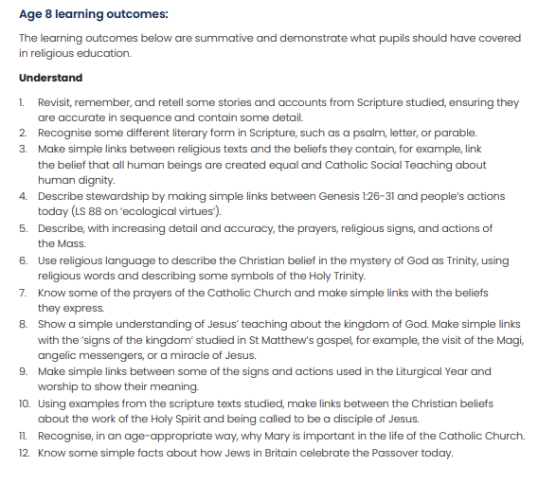
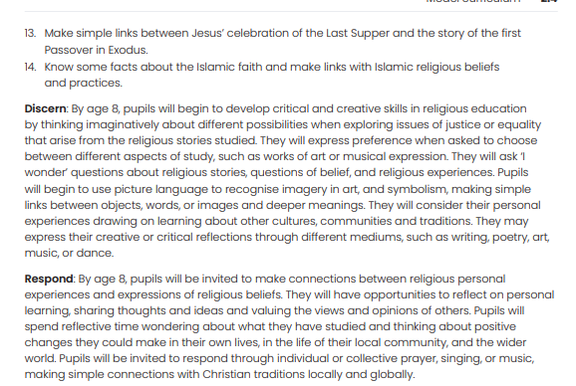

End of Year Four
pupils will be able to:
End of phase standard | End of year descriptor
ER1 | • Ask and respond to questions about their own and other peoples’ experiences and feelings
KU1 | • Retell a narrative that is accurate in its sequence and detail and corresponds to the scripture source used – e.g. Abraham, Moses, David, Joseph, Jonah and stories from Holy Week
KU2b | • Describe, with increasing detail and accuracy, actions of believers which arise because of their beliefs, e.g. Abraham, Moses, David, Joseph, Jonah, Mary, Joseph, Jesus and the disciples at Pentecost
KU2c | • Describe, with increasing detail and accuracy, the life and work of key figures e.g. St. Peter, St. Paul, St. Teresa of Calcutta, Pope St. John Paul II
KU2d | • Describe, with increasing detail and accuracy, different roles of people in the Church e.g. in the parish community
KU2e | • Describe, with increasing detail and accuracy, religious signs and actions in worship and sacraments e.g. the Mass
KU3a | • Make links between beliefs and sources e.g. beliefs that Jesus is truly God and man and bible texts, beliefs about the Mass and their sources in the Bible (Exodus, The Last Supper) and the Apostles’ Creed, giving reasons for the beliefs using those sources
KU3b | • Make links between beliefs and worship e.g. beliefs and the Mass, Holy Week and Pentecost giving reasons for actions and the signs used
KU3c | • Make links between beliefs and how they are put into practice in life e.g. St. Teresa of Calcutta, Pope St. John Paul II and their own lives
ER2 | • Make links to show how feelings and beliefs affect their own and other peoples’ behaviour e.g. their feelings and views about Christmas, about the need to live out certain virtues, about Jesus, Peter, the disciples before and after Pentecost, and other biblical and key figures
KU4 | • Use a range of religious vocabulary
AE1 | • Use a given source to support a point of view e.g. during work on Trust in God, the Creed or the Magnificat and how they affect or reflect the life of a believer or Mary
AE2 | • Express a point of view about any area of study e.g. how is the church both a building and a people?
Upper Key Stage Two Expectations
End of Year Five
Pupils will be able to:
End of phase standard | End of year descriptor
KU1 | • Show knowledge of a range of scripture passages e.g. Creation and Fall, Abraham, Moses and the Ten Commandments, the Old Testament prophets, the Beatitudes, stories about forgiveness, Holy Week, texts on prayer, the first Christians and show some understanding of the concepts and beliefs they contain.
KU2a | • Show knowledge and some understanding of the meaning of a range of religious beliefs e.g. creation, sin, stewardship, covenant, the Incarnation, the call to sainthood, the importance of forgiveness and reconciliation, the Resurrection, the importance and effect of prayer
KU2b/ KU2c | • Show knowledge of the life and work of key figures e.g. St. Paul, St. Francis, St. Josephine Bakhita, St Edith Stein, Blessed Miguel Pro, Fr. Pedro Arrupe, St. Leopold Mandic, St. Damien de Veuster and show some understanding of their life and work
KU2d | • Show some understanding of what it means to belong to the church community e.g. the commitment necessary of a follower of Jesus, the importance and effect of prayer
KU2e | • Show knowledge and some understanding of the meaning of religious signs and the steps involved in the Sacrament of Reconciliation.
ER2 | • Show knowledge of the actions and decisions of believers and some understanding of how these actions and decisions are informed by beliefs (how these beliefs motivate, inspire or help) e.g. Abraham and Moses and their call from God, St. Josephine Bakhita, St. Edith Stein, Blessed Miguel Pro, Fr. Pedro Arrupe, St. Leopold Mandic and St. Damien de Veuster, Saul and St. Paul and pupils themselves
KU3a | • Show some understanding of beliefs by making links with sources e.g. Sin and suffering in the world and the Fall in Genesis, beliefs about God, the Incarnation and the Old Testament prophets, discipleship and scripture sources, reconciliation and the Lost Son, God as loving and forgiving and scripture sources, reconciliation and sources from the life of Jesus, our redemption from sin and the Resurrection
KU3b | • Show some understanding of beliefs by making links with their expression in worship e.g. the Holy Spirit’s presence among us and its expression in religious signs and actions, Jesus’ teaching on prayer and its place in Christian worship
KU3c | • Show some understanding of beliefs by making links with how they are put into practice and applied to life e.g. Ten Commandments, the virtues, the Beatitudes, reconciliation, discipleship
KU4 | • Use religious vocabulary widely, accurately and appropriately
ER1 | • Compare their own and other peoples’ responses to questions of meaning and purpose e.g. why people suffer, use of own gifts, God’s choice of people, the Incarnation, who is inspirational?, the consequences of actions, discipleship
AE1 | • Use sources to support a point of view e.g. passages from the creation story; that someone is inspirational, passages on forgiveness and reconciliation
AE2 | • Express a point of view and give a reason for it e.g. discipleship
AE3 | • Begin to arrive at judgements e.g. why someone is inspirational

End of Year Six
Pupils will be able to:
End of phase standard | End of year descriptor
KU1 | • Show knowledge of a range of scripture passages e.g. parables, miracles, Old Testament prophets, Annunciation, Visitation, Nativity of Jesus, Exodus (Passover), Holy Week texts, Pentecost text, Genesis (made in God’s image, creation of man), Body of Christ, and show understanding of the concepts and beliefs they contain
KU2a | • Show knowledge and understanding of the meaning of a range of religious beliefs e.g. Kingdom of God, Justice, Incarnation, Covenant, Sacrament, Eucharist, Confirmation, titles used of Jesus (King, Messiah, Son of God), Dignity, Service, Solidarity, Mercy, the Church as the Body of Christ
KU2b/ KU2c | • Show knowledge of the life and work of key figures e.g. St. Therese of Lisieux, Elijah, St. John the Baptist, Oscar Romero, Dorothy Day, Martin Luther King and show an understanding of their life and work
KU2d | • Show understanding of what it means to belong to the church community e.g. Christians are called to work for justice, the impact of the Eucharist on action in the world, use of gifts and talents in the service of others, commitment to worship and sacraments, performing the works of mercy
KU2e | • Show knowledge and understanding of the meaning of religious signs and the steps involved in the Sacrament of the Eucharist and Confirmation
ER2 | • Show knowledge of the actions and decisions of believers (and themselves) and understanding of how these actions and decisions are informed by beliefs (how these beliefs motivate, inspire or help) e.g. beliefs about the Kingdom of God, Justice, Gifts of the Holy Spirit, Dignity, Equality, Solidarity
KU3a | • Show understanding of beliefs by making links with sources e.g. Kingdom of God and parables and miracles, justice and texts from the prophets, Incarnation and the Annunciation, Visitation and Nativity, Self-giving sacrifice (Last Supper) and the Passover, Son of God / Messiah and scripture passages, Nature of discipleship and texts about the call and life of the disciples, Human dignity and texts from Genesis (made in God’s image)
KU3b | • Show understanding of beliefs by making links with their expression in worship e.g. beliefs expressed in different parts of the Mass, beliefs expressed in worship during Holy Week (Palm Sunday, Maundy Thursday, Good Friday, Easter Sunday), beliefs about the effect of the Holy Spirit and Confirmation
KU3c | • Show understanding of beliefs by making links with how they are put into practice and applied to life e.g. Kingdom of God and applying St. Theresa’s ‘Little Way, Justice, the Eucharist’s impact on action, Service of others, putting belief in human dignity and equality in action
KU4 | • Use religious vocabulary widely, accurately and appropriately
ER1 | • Compare their own and other peoples’ responses to questions of meaning and purpose e.g. the Kingdom of God, the Eucharist and the Mass, whether miracles happen or not, belonging to communities including the Church
AE1 | • Use sources to support a point of view e.g. Kingdom of God, Incarnation (what kind of king is Jesus?), discipleship and service
AE2 | • Express a point of view and give reasons for it e.g. the Kingdom of God, Incarnation, Eucharist and the Mass, whether miracles happen, inequality
AE3 | • Arrive at judgements e.g. on miracles, on what’s more important i.e. heaven or justice and peace in the world
AE4 | • Recognise difference, comparing and contrasting different points of view e.g. justice, whether the Trial of Jesus was a fair trial, different views about the Messiah, whether miracles happen, views about inequality

