Dean Gibson Catholic Primary School
Swifts Class Curriculum Overview
2023-2024
 | Autumn Term |  |  | Spring Term |  |  | Summer Term
English
Year 2 and 3 | 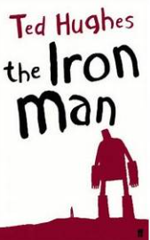 | 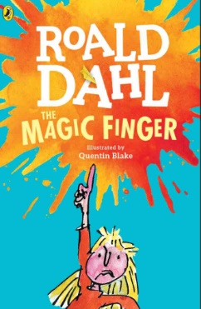 |  | 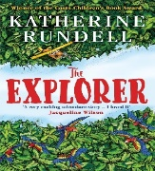 |  | 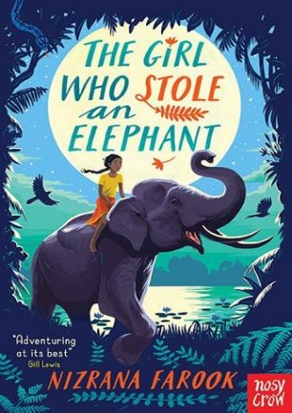 | 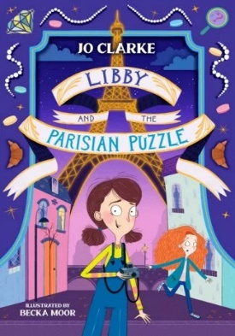 | 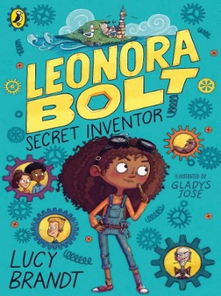
 | Genres
 | Narrative  Instructions | Balanced argument  Poetry |  | Narrative  Non-chronological report,  Persuasive writing. |  | Poetry  Explanation | Narrative  Letters/Postcards  Journalist report | Poetry  Instructions
Maths
Year 3 and 4 | Number  -Place Value  (within 1000) Y3  Number  -Place Value  Y4  Number  -Addition & Subtraction  (within 1000 inc Money) Y3  Number  -Addition & Subtraction Y4 | Number  -Addition & Subtraction Y3&4  Number  -Multiplication&  Division A Y3&4  Measurement  Area- Y4 |  | Number  -Multiplication&  Division B Y3&4  Measurement  Length, Perimeter  & Area Y3&4  Number  -Fractions Y3&4 |  | Number  -Fractions Y3&4  Measurement  -Mass&Capacity Y3  Number  -Decimals Y4 | Number  -Fractions Y3  Number  -Decimals Y4  Measurement  -Money Y3&4  Measurement  Time Y3&4  Geometry  -Shape Y3&4 | Statistics  Y3&4  Geometry  -Position&  Direction Y4
RE
Year 3 and 4 | The Bible | Trust in God |  | Jesus the  Teacher | Jesus the  Saviour |  | The Mission of the Church |  | Belonging to the Church
Science
Year 3 and 4 | Light and Sound  Rocks |  | Particle model and states of matter  Plants |  |  |  | Organisms  Electricity
Art
Year 3 and Year 4 | Pattern and Pumpkins |  | Watercolour Tropical Rainforests |  |  |  | My Favourite Things
Music
Year 3 and Year 4 | Writing music down  Playing in a band |  | Compose using your imagination  More musical styles |  |  |  | Enjoying improvisation  Opening night

Geography
Year 3 and Year 4 | The United Kingdom  (Volcanoes) | Tropical Rainforests  (looking at South America and Brazil) | Looking at Europe and Tourism  (Earth quakes and Settlements)
History
Year 3 and Year 4 | History: Ancient Maya  (Ancient Greece) | Early Islamic Civilisation  (Ancient Egypt) | European Local History  (Prehistoric Britain)
Computing
Year 3 and Year 4 | Computing systems and networks – connecting computers  Creating media – stop frame animation | Programming – sequencing sounds  Data and information – branching databases | Creating media – desktop publishing  Programming – events and actions in programs
PE
Year 3 and Year 4 | Football / Swimming | Cricket/ Gymnastics / Hockey Rugby  Swimming | Yoga / Cricket / Hockey / Rugby
Design Technology
Year 3 and  Year 4 | Shell structures using CAD software | Levers and linkages | Simple circuits and switches
Spanish
Year 3 and 4 | My Town  Sign of the Cross and  Hail Mary  Let’s Go!  Christmas in Spain | Shopping  The Wider World  Easter celebrations | My Routine  Free Time

