Books and genre coverage – Dean Gibson Catholic Primary School
2023-2024
Robins
EYFS
Nursery and Reception
Autumn Term |  |  | Spring Term |  |  | Summer Term
Texts |  |  | Texts |  |  | Texts
Me and My World  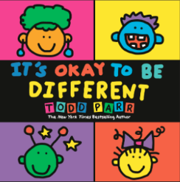  Bears  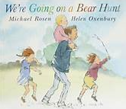  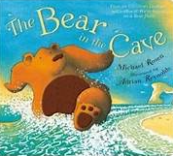  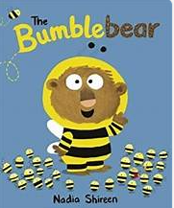  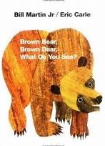 |  | My Heroes and Special Days  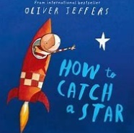  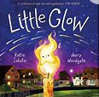  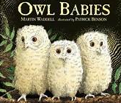  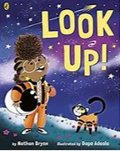  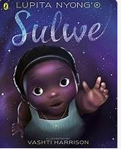 | Castles, Knights and Dragons  On the Move  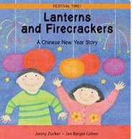  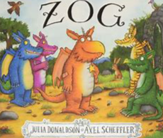  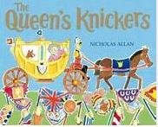  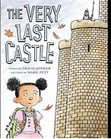  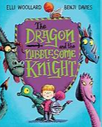  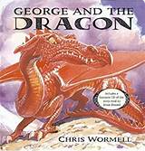 |  | Spring in Our Step  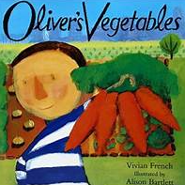  On the Farm  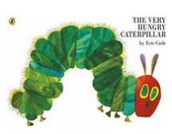  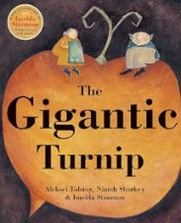  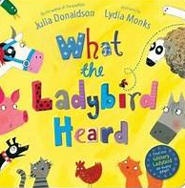  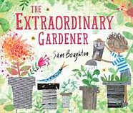 | Where we Live  And Once Upon a Time  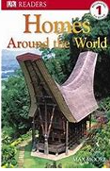  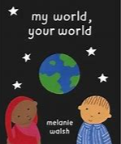  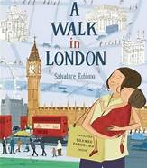  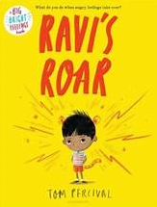  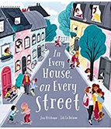  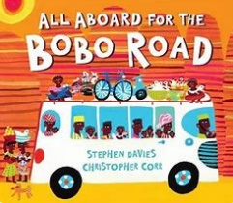 | Science Detectives and All Creatures Great and Small  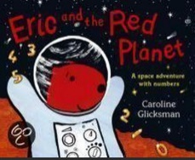  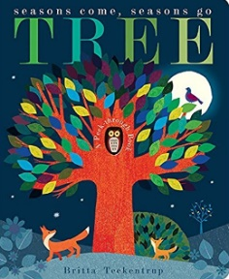  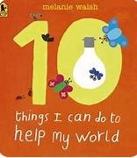  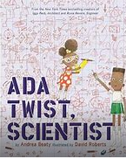  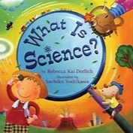
Genres |  |  | Genres |  |  | Genres
Narrative (retell)  Labels and captions  Thought/speech bubbles | Poetry  Performance  Nursery Rhymes |  | Narrative – predictions/ problem solving  Instructions  Letter | Poetry  Repetitive phrases and adding alternative rhyming words |  | Narrative – alternative endings  Non-chronological report  Post card |  | Poetry  Responding to and writing poetry
Sparrows
Year 1
Autumn Term |  |  | Spring Term |  |  | Summer Term
Texts |  |  | Texts |  |  | Texts
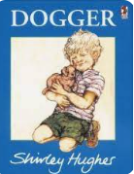 | 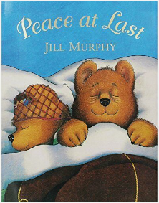  Also, a recount from a vet visit. |  | 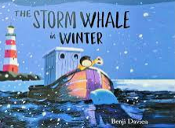 | 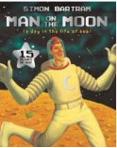 |  | 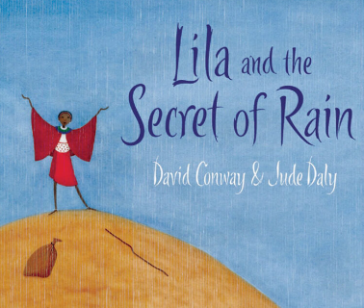 |  | 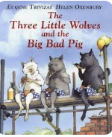
Genres |  |  | Genres |  |  | Genres
Narrative | Letter  Poetry  Recount |  | Narrative  Non-chronological reports about whales. | Poetry  Postcards  Persuasive Writing |  | Narrative  Diary |  | Poetry  Instructions  Newspaper
Finches
Year 2/Year 3
Autumn Term |  |  | Spring Term |  |  | Summer Term
Texts |  |  | Texts |  |  | Texts
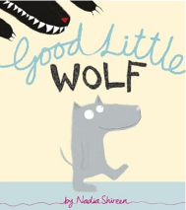  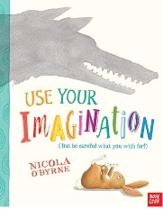  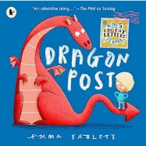 | 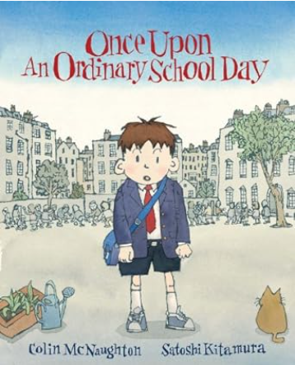 |  | 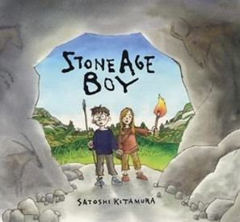  History – Prehistoric Britain  Science Plants:  Best children's books - Growing Plants Topic (booksfortopics.com) | Geography – Hot and Cold Deserts.  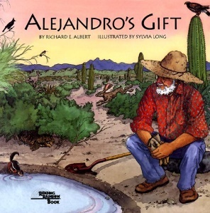  Science- Living Things and their habitats  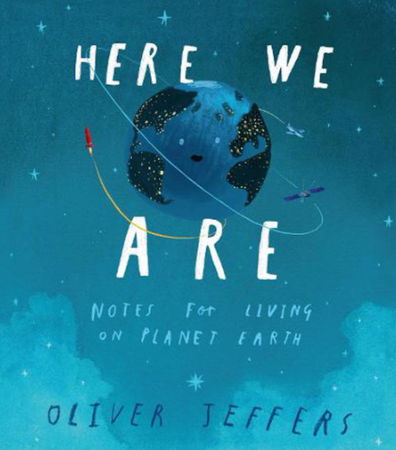 |  | 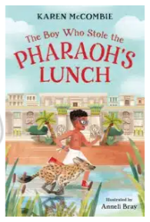  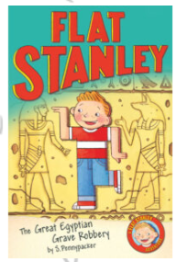  History – Ancient Egypt  Science - Light  Best children's books - Light and Dark Topic (booksfortopics.com) |  | 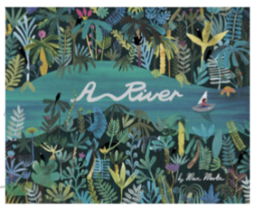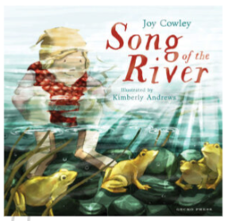
Genres |  |  | Genres |  |  | Genres
Narrative  Letters/postcards | Narrative  Explanations  Poetry |  | Narrative  non-chronological reports, | discussion/balanced argument.  recounts  Poetry |  | Narrative  Instructions  journalist report , |  | persuasive writing, Poetry
Swifts
Year 3/ Year 4
Autumn Term |  |  | Spring Term |  |  | Summer Term
Texts |  |  | Texts |  |  | Texts
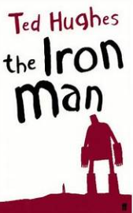 | 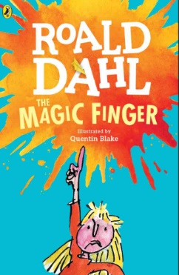 |  | 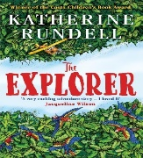 | 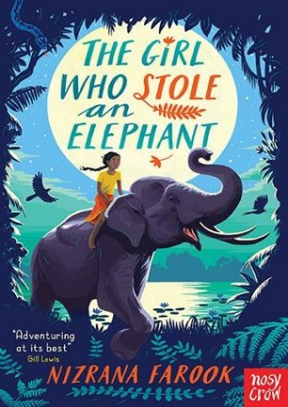 |  | 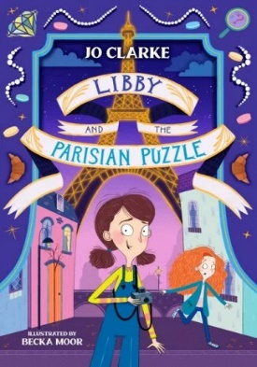 |  | 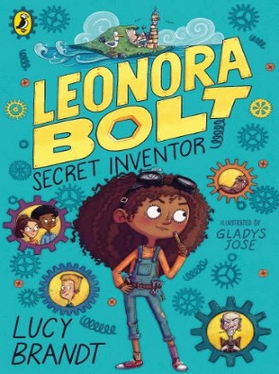
Genres |  |  | Genres |  |  | Genres
Narrative  Instructions | Balanced argument  Poetry |  | Narrative  Non-chronological report,  Persuasive writing. | Poetry  Explanation |  | Narrative  Letters/Postcards  Journalist report |  | Poetry  Instructions
Kingfishers
Year 5
Autumn Term |  |  | Spring Term |  |  | Summer Term
Texts |  |  | Texts |  |  | Texts
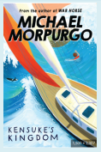 | 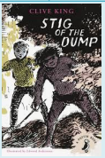 |  | 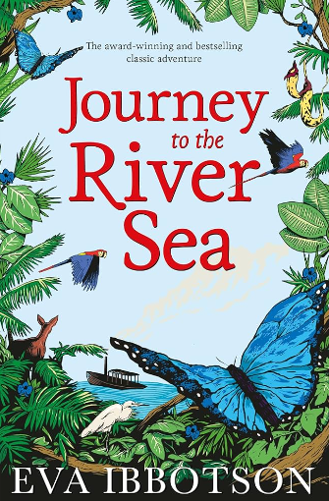 |  |  | 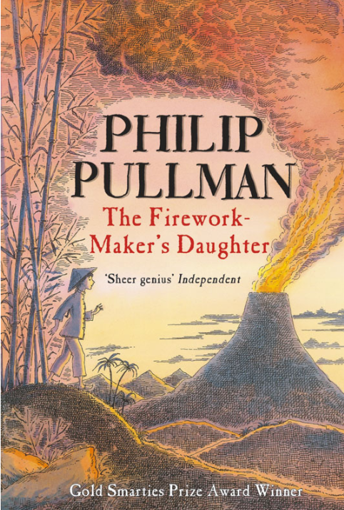 |  | 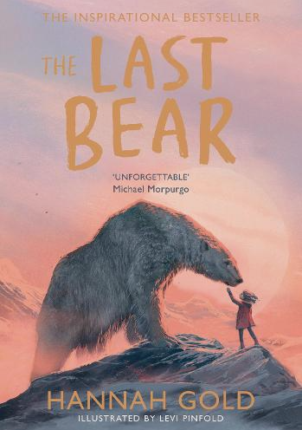
Genres |  |  | Genres |  |  | Genres
Narrative  Non-chronological reports,  Discussion/Balanced argument. | Poetry  Persuasive writing. |  | Narrative  Letters/postcards. | Poetry  Journalist report, Recounts. |  | Narrative  Explanations. |  | Poetry  Instructions.
Eagles
Year 6
Autumn Term |  |  | Spring Term |  |  | Summer Term
Texts |  |  | Texts |  |  | Texts
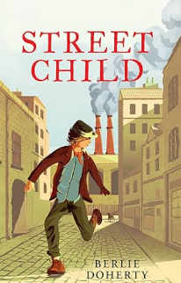 | 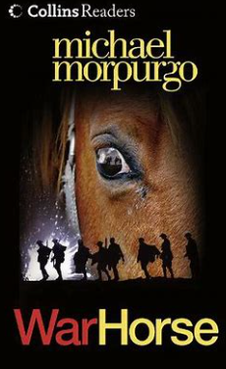  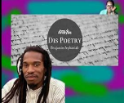 |  | 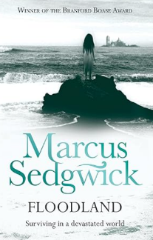 | 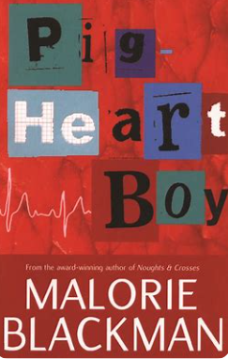 |  | 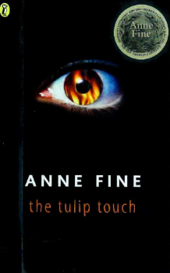 |  | 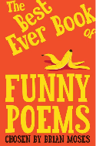  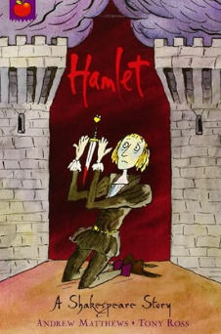
Genres |  |  | Genres |  |  | Genres
Narrative  Letter Writing  Persuasive Writing  Diaries | Poetry  Setting Descriptions  Balanced Arguments |  | Narrative  Journalistic Reports | Non-Chronological Reports  Instructions  Explanation Texts |  | Narrative  Recounts |  | Poetry  Shakespearean Texts

