Books and genre coverage – Dean Gibson Catholic Primary School
Robins
EYFS
Nursery and Reception
Autumn Term |  | Spring Term |  | Summer Term
Texts |  | Texts |  | Texts
Me and My World  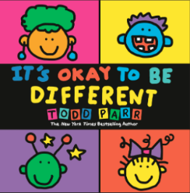  Bears  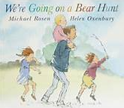  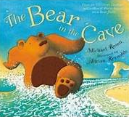  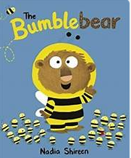  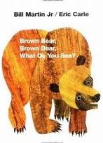 | My Heroes and Special Days  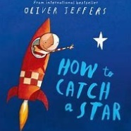  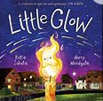  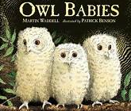  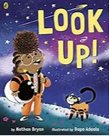  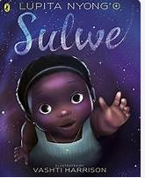 | Castles, Knights and Dragons  On the Move  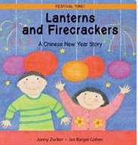  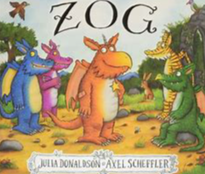  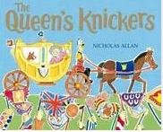  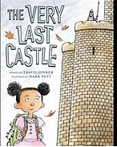  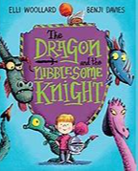  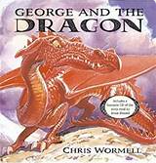 | Spring in Our Step  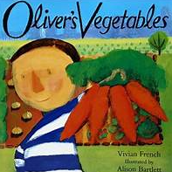  On the Farm  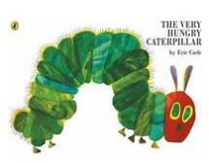  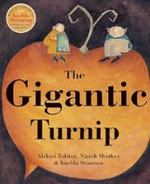  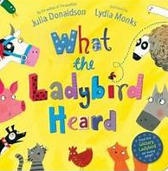  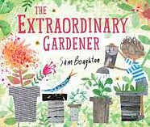 | Where we Live  And Once Upon a Time  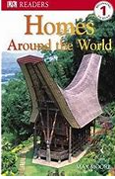  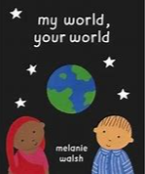  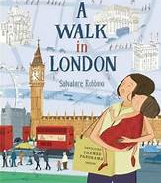  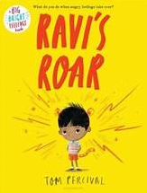  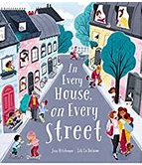  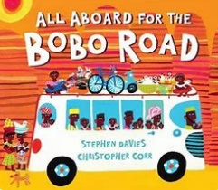 | Science Detectives and All Creatures Great and Small  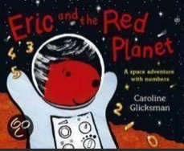  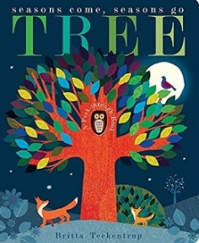  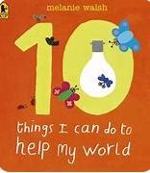  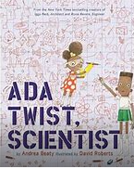  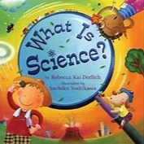
Genres |  | Genres |  | Genres
Narrative (retell)  Labels and captions  Thought/speech bubbles | Poetry  Performance  Nursery Rhymes | Narrative – predictions/ problem solving  Instructions  Letter | Poetry  Repetitive phrases and adding alternative rhyming words | Narrative – alternative endings  Non-chronological report  Post card | Poetry  Responding to and writing poetry
Sparrows
Year 1
Autumn Term |  | Spring Term |  | Summer Term
Texts |  | Texts |  | Texts
Genres |  | Genres |  | Genres
Narrative | Poetry | Narrative | Poetry | Narrative | Poetry
Finches
Year 2/Year 3
Autumn Term |  | Spring Term |  | Summer Term
Texts |  | Texts |  | Texts
Genres |  | Genres |  | Genres
Narrative | Poetry | Narrative | Poetry | Narrative | Poetry
Swifts
Year 3/ Year 4
Autumn Term |  | Spring Term |  | Summer Term
Texts |  | Texts |  | Texts
 |  | 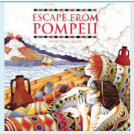
Genres |  | Genres |  | Genres
Narrative | Poetry | Narrative | Poetry | Narrative | Poetry
Kingfishers
Year 5
Autumn Term |  | Spring Term |  | Summer Term
Texts |  | Texts |  | Texts
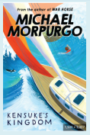 | 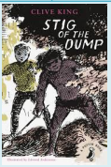
Genres |  | Genres |  | Genres
Narrative | Poetry | Narrative | Poetry | Narrative | Poetry
Eagles
Year 6
Autumn Term |  | Spring Term |  | Summer Term
Texts |  | Texts |  | Texts
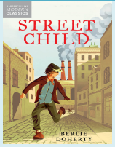

Genres |  | Genres |  | Genres
Narrative | Poetry | Narrative | Poetry | Narrative | Poetry

