Art and Design
Policy
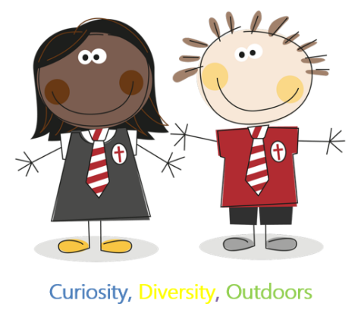
At Dean Gibson Catholic Primary School our children are Artists.

Art and Design at Our School
Our Curriculum is designed with our children in mind. We strive to provide essential knowledge that children need to prepare them for their future success. It is about giving them the best possible start to their education and as artists we work on providing opportunities that enhance their learning and experiences.

The drivers of our curriculum are: Curiosity, Diversity, Outdoors

Aims of our school:
*To have enjoyment and pride in their artistic and creative abilities.
* To have understanding, appreciation and knowledge related to the artistic experience of the world around them, including the influence artist’s achievements of different cultures, past and present.
* A keen interest in creating their own original artwork and that inspired by existing artists.
* A range of skills using a range of media
* To use personal qualities of confidence, creativity, perseverance and self-evaluation.
*To have an awareness and knowledge of a range of different artist and the impacts that they have.
*To build on previous knowledge and ask and answer intriguing questions.
*To show a curiosity about art.
Subject Leader will:
* review and update Dean Gibson Catholic Primary School’s policies relating to Art and Design
* assisting and advising in the teaching of Art and Design across the school
* ensure that staff have the essential training, resources and knowledge to teach the Art curriculum.
* monitor standards of achievement and progression
* maintaining centrally stored media and resources to enable teaching
* promote and raise the profile of Art and Design throughout the school.
* seek opportunity to enrich
What does an artist need in EYFS?
- Access to a wide range of media such as paint, watercolour, clay, paper, textiles, play dough, recycled material and more in continuous provision and in lesson time.
- Access to different tools to work with different media.
- To learn about, take inspiration from, ask questions about and share thoughts on existing artist’s work.
- Independent time
- Vocabulary.
- Talk Time.
- Opportunities experiment with a wide range of different media
- Experiences in galleries.
- Opportunity to take inspiration from and create art in the outdoors.
- Opportunity to respond to national events through art.
What does an artist need in KS1?
- A knowledge organiser
- Opportunity to use and work with a wide range of media such as paint, watercolour, clay, charcoal, pencils, paper, textiles, recycled material
- Access to different tools to work with different media.
- To talk about their likes and dislikes with their own, and others, artwork.
- Topic specific vocabulary.
- To learn about, take inspiration from, ask questions about and share thoughts on existing artist’s work.
- Educational visits and opportunity to work with specialists in their field.
- Opportunities experiment with a wide range of different media
- Experiences in galleries
- Opportunity to respond to national events through art.
What does an artist need in KS2?
- A knowledge organiser
- Opportunity to use and work with a wide range of media such as paint, watercolour, clay, charcoal, pencils, paper, textiles, recycled material
- Access to different tools to work with different media.
- To talk about their likes and dislikes with their own, and others, artwork.
- Topic specific vocabulary.
- To learn about, take inspiration from, ask questions about and share thoughts on existing artist’s work.
- Educational visits and opportunity to work with specialists in their field.
- Opportunities experiment with a wide range of different media
- Experiences in galleries
- Opportunity to respond to national events through art.
Inclusion
- All children at our school will have the opportunity to work with a range of media and techniques, regardless of ability.
- Specific tasks may be differentiated, as and when necessary, to meet individual needs. This will not hinder progress, knowledge building or children’s opportunities.
- Staff should be aware of and be sensitive to medical conditions (e.g. allergies) and different beliefs and practices within the school and local community that might affect their work with food, materials or design.
We will review this policy annually.
Review date : January 2024

