Dean Gibson Catholic Primary School
Robins Class Summer 1 Newsletter
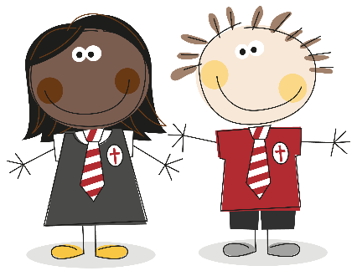
Curiosity, Diversity, Outdoors
Dear Parents and Carers,
We are writing to share with you an overview of the topics that your child will be learning this half of the Summer term in Robins Class as well as some other important information.
Our topics this half term are called Where We Live and Once Upon a Time. Please use the information below to support your child with their learning over the coming weeks.
If you have any questions about the information below, please feel free to make an appointment or catch me for a quick chat.
Thank you for your continuing support,
Mrs Ritchie, Mrs Mackay and Romy.
Below are the topics that we are going to be studying this half term:
Curriculum Overview Summer 1 Robins
Subjects | Robins will be learning about…. | Subjects | Robins will be learning about….
RE | To the Ends of the Earth  - Knowing that Jesus went back to his Father.  - Knowing that Jesus sent his friend the Holy Spirit.  - Knowing that the Holy Spirit is our friend.  - Knowing that Jesus’ friends spread the Good News about Him.  - Knowing that the Parish Church is a special place.  - Knowing that our parish is a family and a community. | History | Where we live  We will be looking at historic pictures of Kendal e.g. important buildings, high street, the school. Talking about what the children notice. What has changed? What is still the same?  We are hoping to Invite parents/ grandparents to talk about what they remember of how Kendal has changed over the years.
English  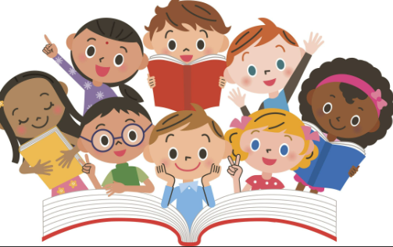 | Narrative – creating alternative endings to well know fairytales.  Non- chronological reports – writing about different countries.  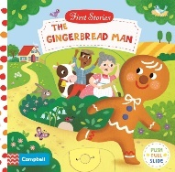  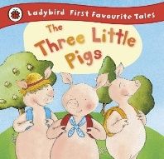  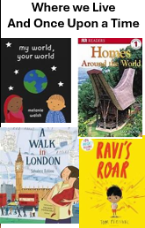  Post cards – writing postcards as characters in stories.  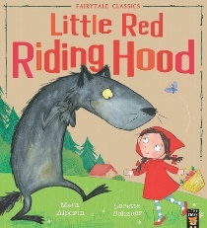  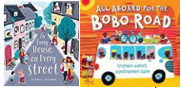 | Art/DT | Once Upon a Time  Using the familiar storylines of traditional tales such as The Gingerbread Man. Little Red Riding Hood and the Three Little Pigs and the Big Bad Wolf we will explore vertical and horizontal lines to detail textures of buildings. We will look at line drawing to show movement in the moment where the wolf blows the house down!  We will look at constructing models of houses in DT and using different materials just like the Three little Pigs!  We would also like to visit the local Art Gallery at Abbot Hall and take a virtual tour of an art gallery in London to compare.
Maths  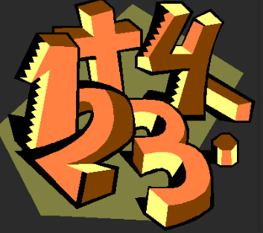 | White Rose Maths  Reception age maths:  -Build numbers beyond 10 (10-13)  -Patterns beyond 10 (10-13)  -To 20 and Beyond  -How many now?  -Manipulate, Compose & Decompose  -Sharing & Grouping  Nursery age maths: | Music | Charanga Music  Big Bear Funk  Musical learning focus:  Listening and appraising Funk music  Embedding foundations of the interrelated dimensions of music using voices and instruments  Learning to sing Big Bear Funk and revisiting other nursery rhymes and action songs  Playing instruments within the song  Improvisation using voices and instruments  Riff-based composition  Share and perform the learning that has taken place
Science | Once Upon a Time  Using stories as a starting point we will be:  Using all their senses in hands-on exploration of natural materials.  Explore collections of materials with similar and/or different properties.  Talk about the differences between materials and changes they notice.  Talk about what they see, using a wide vocabulary.  We will be baking cakes and gingerbread men and noticing what happens to the ingredients as we mix and bake them.  Looking at dissolving – gingerbread men and other materials. Working like scientists to predict, set up a fair test and find out answers to our questions. | PE | Move & Hold:  Gymnastics  Gymnastics is on a Thursday morning with Cam Coaching  Children need to have a PE kit with black shorts, white t-shirt, pumps or trainers and a black/grey hoody.
Geography | Where We Live  By exploring our immediate local environment through going on walks and looking at maps we will contrast Kendal with London and contrasting with the country of Burkino Faso in Africa.  Development matters  Draw information from a simple map.  Recognise some similarities and differences between life in this country and life in other countries.  EYFS Assessment  Describe their immediate environment.  Explain some similarities and differences between life in this country and life in other countries. | HRSE/PSHE | Created to Live in Community  -My Body My Rules  - God is love  -Loving God, Loving Others  -Feeling Poorly  -People who help Us

Our Class Timetable
A week in the Robins looks like this:
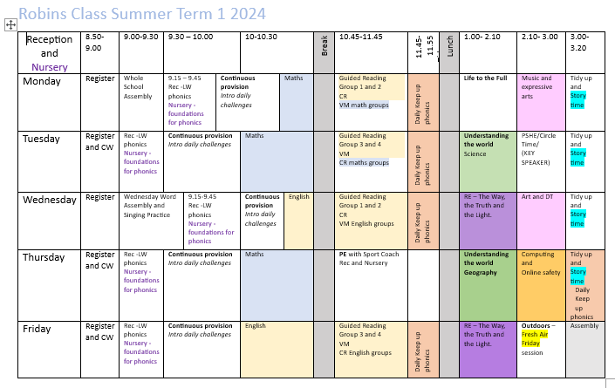
PE
Gymnastics for the Robins Class will be on a Thursday morning, please make sure that you have a PE kit consisting of black bottoms, a white t-shirt and black zip up/hoodie. Children will also need suitable PE footwear.
Outdoor Learning
We will be making the most of outside space and taking our learning outdoors for forest school sessions on a Friday afternoon, ‘Fresh Air Friday’ the children will be wearing wellies and their warm coats for this.
Reading
Thank you for the effort that you put into reading with your child/ren at home. This is the key to developing skills across the curriculum and the more you can do, the more your child will be able to use these skills in all areas of their learning. Remember to talk to your child about what they are reading as well as listening to them – the type of questions that need an explanation should be combined with fact finding questions. Reading books will continue to be changed in class on a Monday and we will also select from the Library box on a Friday to simply enjoy with you at home. Bookbags should be brought to school each day.
Uniform Reminder
Please could you ensure that all uniform including jumpers and ties, PE kits, lunch boxes, water bottles and coats etc. are named.
Please could children only wear shoes with laces if they can tie them. When they next grow out of their shoes/boots please get shoes with a Velcro or buckle fastening. This is for the safety of the children in the environment and to increase independence.
Snacks
Fruit is provided in class for snacks during morning playtime. If your child/ren wishes to bring a healthy snack i.e. a different piece of fruit, cereal bar etc. to enjoy from home rather than our fruit, please make sure that this is in their bookbags, ready to be stored in their trays once they come into class.

