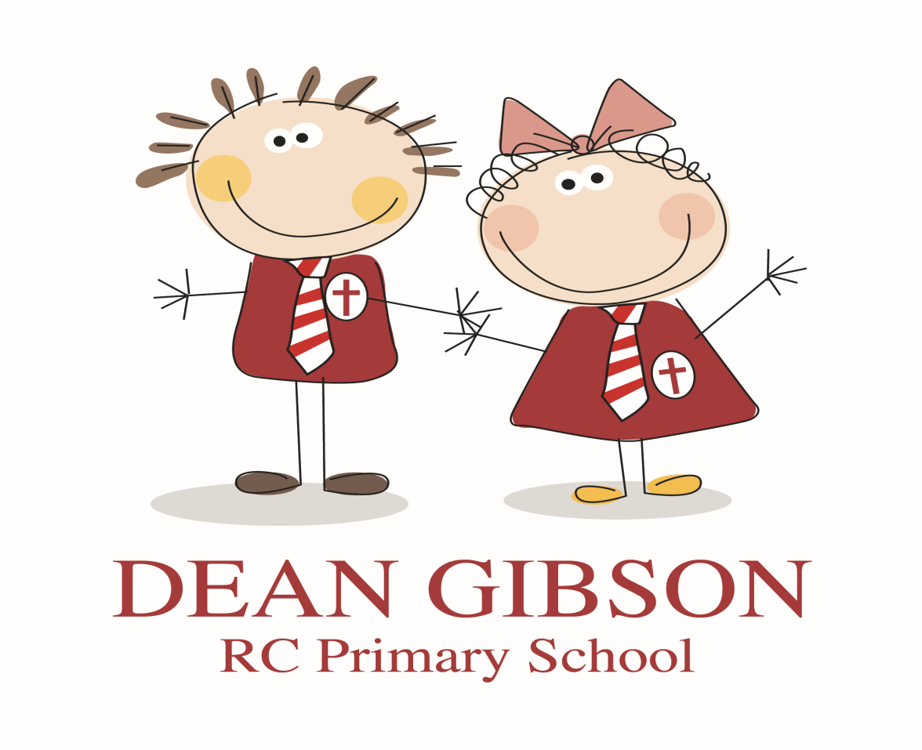
CHILD PROTECTION POLICY
(ANNEX RE COVID-19)
2020

Signed by the Chair of Governors:
Date:

Dean Gibson School Child Protection Policy

Annex to Child Protection policy version 1.0 – Safeguarding procedures during the Covid-19 Pandemic

Context

The way schools and colleges are currently operating in response to coronavirus (COVID-19) is fundamentally different from business as usual. Most children are no longer in a school setting and staff numbers have been affected by the outbreak.

Schools have been asked to provide care for children who are vulnerable and children whose parents are critical to the COVID-19 response and cannot be safely cared for at home.
This annex to our Child Protection policy sets out details of our safeguarding arrangements for:
- Version control and dissemination
- Safeguarding priority
- Current school position
- Safeguarding partners’ advice
- Roles and responsibilities
- Vulnerable children
- Increased vulnerability or risk
- Attendance
- Reporting concerns about children and staff
- Safeguarding training and induction
- Safer recruitment/volunteers and movement of staff
- Peer on peer abuse
- Online safety
- New children at the school
- Supporting children not in school

Version control and dissemination

This is version 1.0 of this annex. It will be reviewed by our designated safeguarding lead (DSL) or a deputy DSL on a weekly basis as circumstances continue to evolve or following updated Department for Education advice or guidance. It is available on the school website and has been made available to staff by internal staff email. Lou Mahon) or one of the Deputy DSLs, (Sarah Tansey and Emily Martin) if not present in the building whenever child care is taking place, will be contactable by telephone. If this is not possible due to self-isolation in the future alternative arrangements will be made at that time, and all staff made aware of them through the circulation of an updated version of this document with highlighted changes in it.

Safeguarding priority
During these challenging times the safeguarding of all children at our school – whether they are currently at home or in attendance – continues to be our priority. The following fundamental safeguarding principles remain the same:
- the best interests of children continue to come first
- if anyone in our school has a safeguarding concern, they will act immediately
- a designated safeguarding lead (DSL) or deputy DSL will always be available
- no unsuitable people will be allowed to gain access to children
- children should continue to be protected when they are online

Current school position

Dean Gibson is not acting as a hub school; all Kendal schools are providing childcare for those children in their own school population who need it. There is a plan written ready to move to a hub school system at Ghyllside school if that situation arises, but this is not foreseen to be the case in at least the short to medium term. If this situation does arise in the future then this annex will be updated accordingly.
At present all childcare provision at Dean Gibson is being provided by our own staff, (no external staff or volunteers,) in our school hall.
If in the future Dean Gibson staff are required to attend Ghyllside to support Dean Gibson children, they will complete an induction to ensure they are aware of safeguarding risks and know how to act if they have concerns. Again, we do not foresee this needing to happen in at least the short to medium term.

Safeguarding partners’ advice

We continue to work closely with our three safeguarding partners, and we will ensure this annex is consistent with their advice. This will include expectations for supporting children with education, health and care (EHC) plans, the local authority designated officer and children’s social care, reporting mechanisms, referral thresholds and children in need. The mechanisms for doing this remain the same as those outlined in our current Child Protection Policy. A REMINDER TO STAFF THAT THEIR FIRST ACTION IN RELATION TO ANY SAFEGUARDING CONCERN SHOULD BE TO CONTACT THE DSL OR DEPUTY DSL WHO IS ON SITE.

Roles and responsibilities

The roles and responsibilities for safeguarding in our school remain in line with our Child Protection Policy.

Our DSL, or one of our deputy DSLs will be available either on site during the school day, or contactable by telephone.

If the DSL or a deputy DSL is not on site please contact them via phone:
The designated safeguarding lead (DSL) for child protection is Lou Mahon
Contact details: email: L.Mahon@deangibson.cumbria.sch.uk tel: 07486379669
The deputy designated lead(s) are Sarah Tansey and Emily Martin
Contact details: email:STansey@deangibson.cumbria.sch.uk tel: 07507 231 760
Contact details: email Emartin@deangibson.cumbria.sch.uk tel: 07743063544

Vulnerable children
The Government has defined vulnerable children as those who have a social worker and those children and young people up to the age of 25 with education or health care (EHC) plans. At Dean Gibson we have additional vulnerable children who fall outside of this bracket, and children who fall into this bracket who are not in an overly vulnerable position, (in terms of safeguarding,) because of their settled home circumstances.
Those who have a social worker include children who have a child protection plan and those who are looked after by the local authority. A child may also be deemed to be vulnerable if they have been assessed as being in need or otherwise meet the definition in section 17 of the Children Act 1989.
There is an expectation that vulnerable children who have a social worker will attend school, so long as they do not have underlying health conditions that put them at risk. (This may not necessarily be the case for ‘settled’ children who have a social worker or those who would find attending the setting challenging.) Where a parent does not want their child to attend school, and their child is considered vulnerable, we will discuss this with the social worker and other agencies to ensure that there are checks on the family provided by those other agencies.
Those with an EHC plan will be risk-assessed in consultation with the local authority and parents to decide whether they need to continue to be offered a school place in order to meet their needs, or whether they can safely have their needs met at home. This could include, if necessary, carers, therapists or clinicians visiting the home to provide any essential services. Many children and young people with EHC plans can safely remain at home.
We will encourage our vulnerable children and young people to attend a school, including remotely if needed.
Senior leaders in our school, especially the DSL (and deputies) know who our most vulnerable children are, and they have the flexibility to offer a place to those on the edge of receiving children’s social care support. At Dean Gibson we are, and expect to continue to, offer children in this situation care.
We will continue to work with children’s social workers and the local authority virtual school head (VSH) for looked-after and previously looked-after children.

Increased vulnerability or risk
Negative experiences and distressing life events, such as the current circumstances, can affect the mental health of pupils and their parents. Staff will be aware of this in setting expectations of pupils’ work where they are at home. Where we are providing for children of critical workers and vulnerable children on site, we will ensure appropriate support is in place for them.
Our staff will be aware of the mental health of children and their parents and carers and will contact the DSL or a deputy if they have any concerns.

Attendance
Where a child is expected but does not arrive at school, we will follow our attendance procedure and attempt to contact the family. If contact cannot be made, the DSL or a deputy DSL will be informed.
The DSL or a deputy will attempt to contact the parents by telephone, or by contacting a relative in the first instance. If contact cannot be made or if the DSL or a deputy DSL deems it necessary, we will ask an appropriate agency to do a home visit . A risk assessment will be carried out before any such visit is made to ensure staff the family are not put at risk.
Where a vulnerable child does not take up their place, we will notify their social worker.

Reporting concerns about children or staff
The importance of all staff acting immediately on any safeguarding concerns remains. Staff will continue to follow our Child Protection procedures found in our Child Protection Policy and advise the DSL of any concerns they have about any child, including those who are not attending school. A REMINDER TO STAFF THAT THEIR FIRST ACTION IN RELATION TO ANY SAFEGUARDING CONCERN SHOULD BE TO CONTACT THE DSL OR DEPUTY DSL EITHER ON SITE OR BY TELEPHONE.
The varied arrangements in place as a result of the COVID-19 measures do not reduce the risks that children may face from staff. As such, it remains extremely important that any allegations of abuse made against staff attending our school are dealt with thoroughly and efficiently and in accordance with our Code of Conduct for staff and other adults and Disciplinary policies.

Staff training and induction
For the duration of the COVID-19 measures, our DSL and deputy DSLSs are unlikely to receive their refresher training. In line with government guidance, our trained DSLs and deputy DSLs will be classed as trained even if they cannot receive this training.
All current school staff have received safeguarding training and have read Part One and Annex A of Keeping Children Safe in Education. If new staff are recruited or volunteers join us, they will receive a safeguarding induction in accordance with our Child Protection Policy.
If staff from another setting attend the school site then, in line with government guidance, we will not undertake any additional safeguarding checks if the setting providing those staff confirm that:
- the individual has been subject to an enhanced DBS and children’s barred list check and, that in the opinion of that setting, nothing resulted from those checks that provided any caused for concern
- there are no safeguarding investigations into the conduct of that individual
- the individual remains suitable to work with children.

Safer recruitment/volunteers and movement of staff
(We do not foresee using volunteers or staff from other schools at Dean Gibson for at least the short to medium term – this section is included for reference in case this document needs to be updated to allow for this in the future.)
It remains essential that people who are unsuitable are not allowed to enter the children’s workforce or gain access to children.
When recruiting new staff, we will continue to follow our Safer Recruitment policy.
In response to COVID-19, the Disclosure and Barring Service (DBS) has made changes to its guidance on standard and enhanced DBS ID checking to minimise the need for face-to-face contact.
For volunteers we will continue to follow the checking and risk assessment process set out in paragraphs 167 to 172 of Keeping Children Safe in Education 2019. Under no circumstances will a volunteer who has not been checked be left unsupervised or allowed to engage in regulated activity.
It is essential from a safeguarding perspective that we are aware, on any given day, which staff/volunteers are on our school site and that the appropriate checks have been carried out on those individuals. We will continue to maintain our single central record (SCR) during these measures to ensure we have this awareness.

Peer on peer abuse
We recognise that children can abuse their peers and our staff are clear about the school’s policy and procedures regarding peer on peer abuse. All peer on peer abuse is unacceptable and will be taken seriously. We also recognise that abuse can still occur during a school closure or partial closure and between those children who do attend the school site during these measures.
Our staff will remain vigilant to the signs of peer-on-peer abuse and will follow the process set out in our Child Protection Policy.

Online safety
It is likely that children will be using the internet and engaging with social media far more during this time. Our staff are aware of the signs of cyberbullying and other online risks and our filtering and monitoring software remains in use during this time to safeguarding and support children.
Our staff will follow the process for online safety set out in our Child Protection Policy.
Staff who interact with children online will continue to look out for signs a child may be at risk. If a staff member is concerned about a child, that staff member will follow the approach set out in this annex and report that concern to the DSL or to a deputy DSL.

Online safety for those children in childcare at Dean Gibson
While children are at Dean Gibson all use of school computers will be supervised, children’s personal mobile phones will be handed in when they arrive and returned to them as they leave, and staff will not use their own personal mobile phones while with the children unless in an exceptional circumstance / emergency situation.

Potential for attending a school hub at Ghyllside
If this were to occur in the future the expectation expressed to, and accepted by, other Kendal schools is that the children involved would be accompanied by staff from the school(s) concerned
Children may attend the hub provision at Ghyllside in the future. When they do, we will share relevant welfare and child protection information, particularly if vulnerable children are involved.
For vulnerable children we will ensure the DSL at Ghyllside understands the reasons for the vulnerability and any arrangements in place to support them. As a minimum we will share that child’s EHC plan, child in need plan, child protection plan or, for looked-after children, their personal education plan and details child’s social worker (and, for looked-after children, who the responsible VSH is).
Ideally this will happen before a child arrives but where that is not possible it will happen as soon as reasonably practicable.
Any exchanges of information will ideally happen at DSL (or deputy) level, and likewise between special educational needs co-ordinators/named individual with oversight of SEN provision for children with EHC plans. (This is Lou Mahon at Dean Gibson and Emily Garbutt at Ghyllside.) However, it is acknowledged this may not always be possible. Where this is the case our school senior leaders will take responsibility. (Sarah Tansey or Clare Ritchie or Huw Davies or Y’Anne Williamson.)
The DSL from Ghyllside will undertake a risk assessment based on the information received, considering how risks will be managed and which staff needs to know the information.

Supporting children not in school
Where the DSL has identified a child to be on the edge of social care support, or who would normally receive additional pastoral support in school, we will make every effort to have the child in school. If this is not possible the DSL will ensure that a communication plan is in place to support that child. Details of that plan will be recorded in the safeguarding file for that child. It will be reviewed regularly to ensure it remains current during these measures.

