Why Help Children to Learn Tables?

The need to multiply is everywhere – in almost all areas of maths and throughout our normal lives. Budgeting, shopping, craft, DIY and cookery are just a few examples of everyday activities in which we use multiplication tables.

If our children learn their times tables, all of these calculations become much easier. School provides many opportunities for children to practise their tables, but the more we can help them at home, the better.
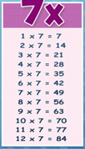
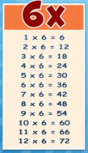
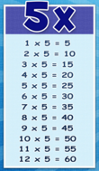
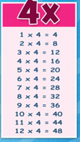
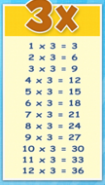
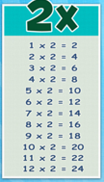
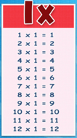
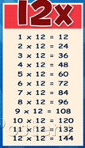
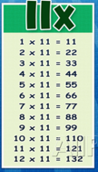
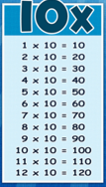
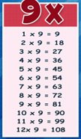
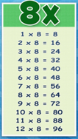
Start With The Easiest And Find A Pattern
All tables have patterns in their numbers. Some of these are easy to spot and some are harder.
Children are introduced to the 2, 5, and 10 times tables first. These all have clear patterns that can help children to learn them, and they are tables that we use a lot.

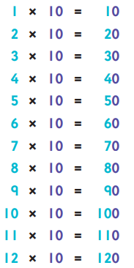
The 10 Times Table
Children spot the pattern of putting a zero on the end of the number that is to be multiplied by 10. This can be useful to help them quickly answer 10 times table calculations, but it’s important for them to understand that although it looks like we have just put a zero on the end of the number we have actually moved its digits to the left and filled the gap with a zero.
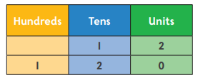

In our number system the position of a digit in a number tells us its value; we call this ‘place value’. Each time we move on place to the left in a number, the value of the digit increases by 10 times.

The 5 Times Table
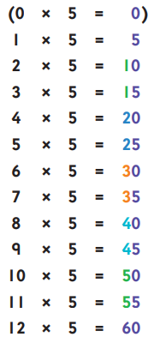
If we include 0 x 5, the digits 0 and 5 repeat themselves over and over again in the units column:
0 5, 0 5, 0 5, 0 5 …
The digit in the tens column goes up by 1 each time this pattern starts again.

The 2 Times Table
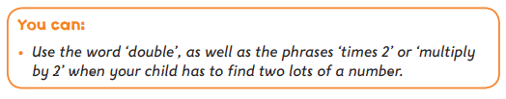
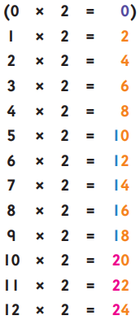
Including 0 x 2, the digits 0 2 4 6 8 repeat over and over again in the units column: 0 2 4 6 8, 0 2 4 6 8. The digit in the tens column goes up 1 each time this string starts again.

Another pattern for the 2 times table is counting in steps of 2: count a number, miss a number, count a number, miss a number and so on.
Doubling And The 4 & 8 Times Tables
Pupils are often shown how doubling, or multiplying by 2, can help with multiplying by 4 and by 8.
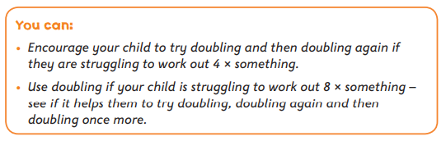
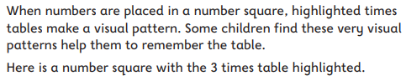

Number Squares
When numbers are placed in a number square, highlighted times tables make a visual pattern. Some children find these very visual patterns help them to remember the table.
Here is a number square with the 3 times table highlighted.
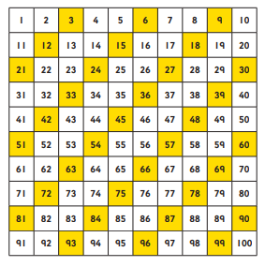

Reciting Tables.

With times tables, there’s nothing like a couple of minutes practice a day to help them stick in the mind. Many children find that reading and hearing themselves say a table regularly helps them to learn it. Here are some reciting tips:
- Find a time and place for reciting that’s easy to keep to. The bathroom at teeth-brushing time can work well as there’s nothing much else to do!
- Just start with the first three or four lines of the table for a few days, and then add one or two more lines each time.
- Each time they practise, ask your child to first read the table from the sheet, and then see how far they can go with their eyes closed. ‘Being able to recall something without looking at it is an important step to getting it lodged in our memory.
- Rhythm, sound, movement, and humour, can all really help us to remember things, so children can give the table a bit of a funky tune and beat as they recite it.
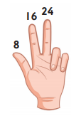
- Some children learn a table best by reciting the whole thing – the calculation (e.g. 3 x 8 = 24). Other children remember the table better if they just recite the answers – 8, 16, 24, and use their fingers to remember which multiple of 8 they have got to.
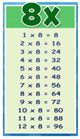
The 9 Times Table Trick
There’s a great trick for recalling the 9 times table which some pupils really enjoy:

To find 4 x 9
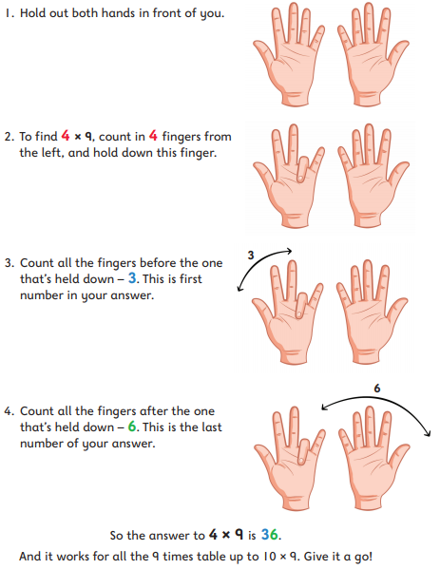
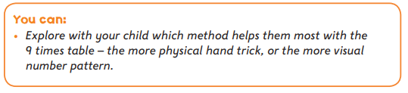
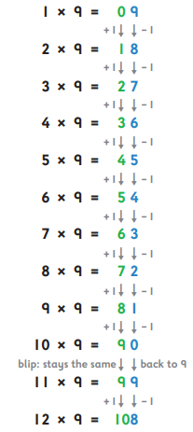
There’s also a nice number pattern in the 9 times table that some children find helps them: the unit number goes down in 1’s and the tens number goes up in 1’s. (You’ll notice that there’s a blip at 11 x 9 but then the pattern picks up again.)

The 11 Times Table

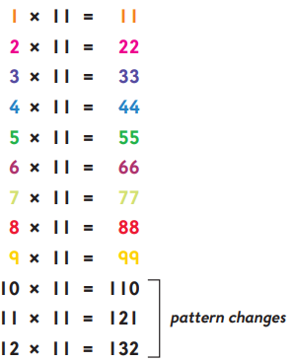
There’s a really clear number pattern in the 11 times table until 9 x 11. Pupils sometimes think the 11 times table is going to be really difficult, so, once they see the pattern it’s a big relief.
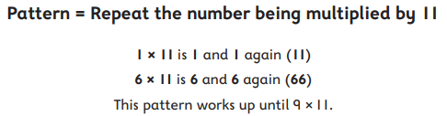

Games
Times table games can be a great way of learning tables. Many games such as Bingo, Snap and Pairs, can be adapted to focus on tables. They make great short, quick-fire games, that can be fitted in any time of the day. Two specific online games we can recommend to help with times tables learning are: Times Table Rockstars and Hit the Button. There are however, many other online games out there to help your child learn their times tables.

Learn A New Times Table In Only 5 Days

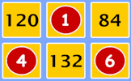
Fast Factors
Begin by writing out your times table on paper; slowly and carefully. Use addition to work out the next number in the sequence. Repeat this ten times then type out a neat copy to print and put up on a wall in your home.
START
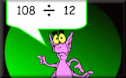
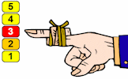
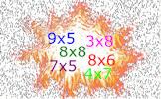
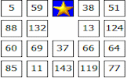
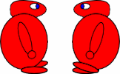
Tablesmaster
Beat The Clock
Quotient Master
Beat The Clock
Tablesmaster
Table Legs
Tables Grab
Flash Tables
Tablesmaster
Tablesmaster
Tables Dash
Tables Conga

