Dean Gibson Catholic Primary School
English Policy
2023 -2024

Writing
Statement of intent:

At Dean Gibson Catholic Primary School, we intend to create confident writers who develop stamina for writing throughout school. We aim for all of our children to be independent writers, building on a range of skills as they work through each journey of writing. Throughout this journey, we ensure the children of Dean Gibson are immersed in a range of genres and have a clear understanding of purpose. Our learners will have a secure understanding of the purpose of a text type, the purpose and intended impact of writing skills/tools and the ability to carefully select vocabulary with careful attention to the desired effect on the readers’ thoughts and feelings. Our learners are challenged and encouraged to take risks and view mistakes as another part of the learning process. Our learners will set high expectations for themselves where they take pride in all aspects of learning and in everything they produce.
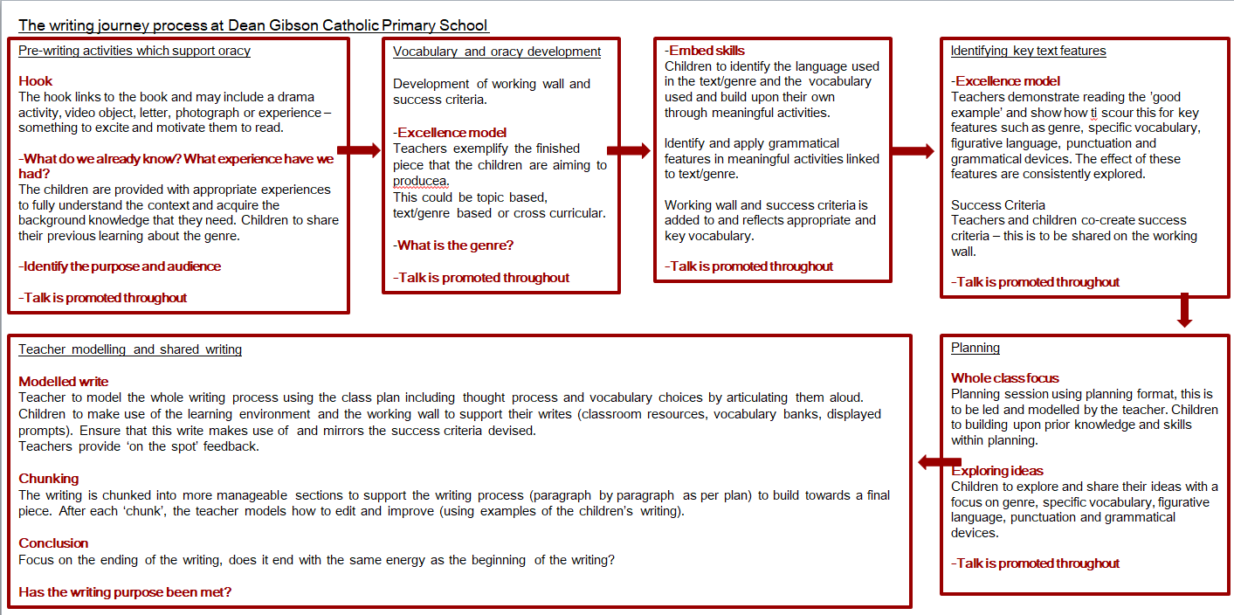
Dean Gibson Catholic Primary School:
-Recognises the effect that a confident, fluent and coherent understanding of English will have on a pupil’s progress, both inside and outside of the school environment.
-Understands how a strong grounding in English will impact the future learning and development of a pupil in all aspects of their life
-Provides a balanced and broad curriculum, which encompasses writing practice, including handwriting, spelling, widening vocabulary, and writing for different styles, purposes, and audiences, as well as focussing on spoken English, reading, grammar and pronunciation.
-Ensures that all staff members are aware of planning, assessment, teaching and learning requirements for the English curriculum.
-Ensures that all pupils know how to plan, practise, evaluate their work as well as carry out an effective edit and improve process.
-Ensures that all pupils understand all elements of English, as per the national curriculum.
Writing Learning Journey and lesson timings
-Each unit of writing will consist of learning done through roughly a 3 week learning journey and will be done through 1 hour lessons at the start of the day of 4 or more sessions a week, this is to ensure that the build-up of knowledge and skills is progressive and clear.
-Prior learning in line with genre and language should be completed with the class at the beginning of the unit and this is returned to at the end of the unit.
-At the beginning of each week a new spelling rule is introduced and referred to throughout, this is delivered through the Twinkl and Little Wandle schemes.
-Although the pedagogical process is detailed for each lesson, teachers have the professional scope to make adjustments where they think they are needed e.g. if more than one lesson is needed to embed a skill or if an extra lesson is needed for drama/speaking and listening then this can be done. There is no need for Learning Journeys to begin on a Monday or to be completed on a Friday.
-There is an expectation that each stage of the learning process takes place and is evident through books, learning environment and planning. Leaning journeys can be based on texts, videos, real life events, images or lyrics from a song (anything that might get the children excited about writing).
The writing learning journey process

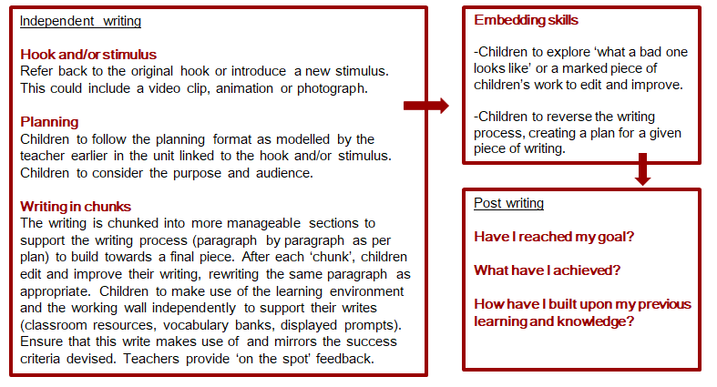
Lesson sequence
 | Spelling rules will be incorporated as part of the learning journey. Rules should be displayed and used in modelling writing, as well as being identified in texts and ‘excellence models’.
Prior Learning
It is important that prior learning is considered.
1 | 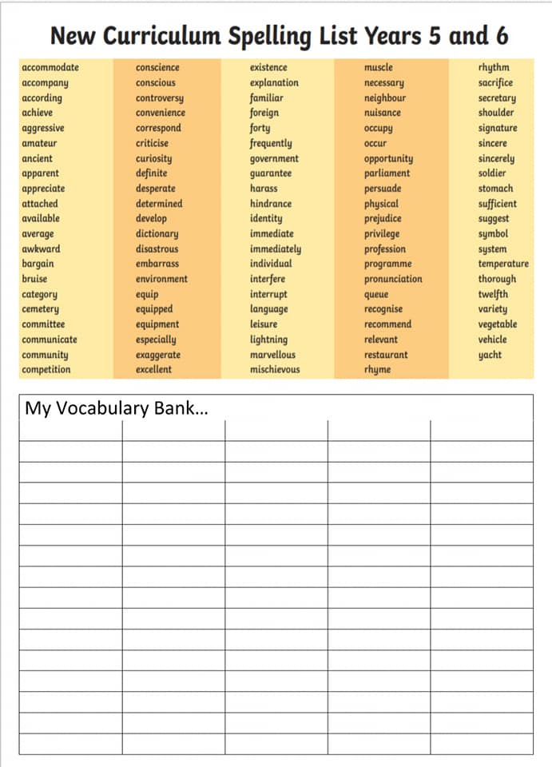  Hook  There must be a hook into the learning journey in order to make the writing engaging and purposeful. These hooks can be small and simple or as extravagant as you want. Using the text to create a purpose can really get the children engaged. You may stage a break-in, show the children a letter from the Prime Minister, dig up a time capsule, put forward a request form the Police for the children to write a description of a suspect etc. This can be a real life experience. It is important that the children become the reader/audience and answer questions on the purpose of the piece and what the writing’s impact is.  - have you learnt from it?  - Are you entertained by it?  - Do you know how to make something successfully?  - Do you know more about the subject?  - Have you been persuaded by the author?  - Are you able to make up your own mind using the evidence you’ve been given?  New vocabulary of the learning journey  This could be derived from the spelling rules taught that week so really consider the rules that have been taught previously and for that week. Always refer to previous and current word lists for age related expectations.  Introduction to the text type/genre through an ‘excellence model’ (what a good one looks like)  Looking at features within the genre including which writing tools are best suited and why with focus on purpose – this shows the children the expectation of what they themselves are aiming for by the end of their unit of work. This should include:  -Features of the genre you are covering (e.g. if you are writing an autobiography it should have key dates, be written in chronological order, first person pronouns etc.)  -New vocabulary of the learning journey  -Evidence of the skill(s) that you will be covering (writing tools).  -Success criteria will be derived.  Where possible, the ‘excellence model’ is to be written by the class teacher, this way you can easily show the above expectations. Great opportunity for responding to the text in reading sessions. Also great to use for fluency of reading. This text could also be sent home prior to the session so the children read it before the lesson. Use the text to practise sentences with grammar features. Adding a paragraph to the text especially if children are confident.
2 | 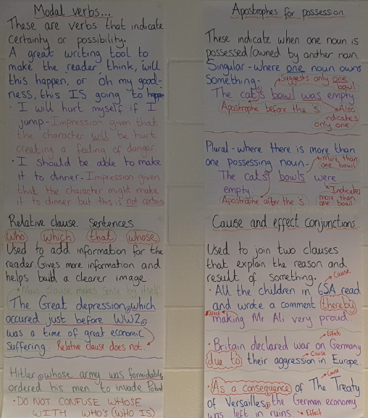  First skill of the learning journey  Here, you will focus on one or two skills that the children will be applying in this unit of work. These must be related to the National Curriculum and should be referred to as ‘Writing Tools’. It is vital that children understand the purpose of the tool they are using and its desired impact on the reader. E.g. I will use contrasting conjunctions as this will help add detail for the reader in relation to an opposite point.  This is an opportunity for the children to fully understand the writing tool/s they will be using. You will produce a guide to place on your working walls for children to refer to as detailed previously.  In KS1 children should be building up their sentence writing. Providing sentence building workshops and free writing areas in EYFS and Year 1 will support this. It is important that children use talk and are confident in sentence building.  These working wall guides may stay up for as long as they are required beyond a unit of work, as children may need to refer to these when applying tools to other writing independently in other curriculum areas.  Based on the first skill you taught the children, they will complete sentence level work in the context of the stimulus they are using to form their own writing e.g. for the video Alma, if you were focussing on the skill of using relative clauses, the children would produce sentences that apply this skill…  -Alma, who was a carefree girl, skipped through the icy streets of the city.  -The workhouse, that was notorious amongst the desolate children of London, was the last place I wanted to go.  These could be done outside of English and it may be good for those who are working towards the expected standard in intervention work.  (This is a great opportunity to use VCOP. Sentence building skills from Alan Peat sentences, spelling rule ….What skill has been chosen?)
3 | Second skill of the learning journey  Here, you will repeat the process of teaching a skill but focussing on a different skill/writing tool. Again, produce a guide for the working wall that will aid children’s understanding and independence.  Talking these sentences is important (improved oracy = improved writing).
4 | Planning stage (related to the hook)  At this point the planning stage should be taught and carried out. This can be done in different ways e.g.  -Planning backwards to show how it is done from the ‘what the good one looked like.’  -Cut out sections and plan each section separately (great for ks1) and bring together.  -KS1 and Y3 -Use pictures within planning stages and show corresponding note that would be used in a formal plan.  -Each table plans in pairs and collaborates.  -Come together and identify misconceptions - make it a good one.  -Planning a whole class piece with cross curricular piece.  -Children can plan their own from this teaching.  Children use the planning frame they’ve been taught (this is a consistent planning format and will be used throughout school). In KS1 children are given a planning frame where they are guided into using the skills taught as part of the learning journey as well as the words of the learning journey. At end of Year 2 they will be introduced to the grid where they add the notes.
5 | Consolidation of skills  Children to complete activity to consolidate learning around the two skills they have learnt so far. It is important that they aim to include vocabulary for the learning journey in their application. Following the second input of a skill/writing tool, here children are expected to produce writing where they are applying the use of both skills learnt during this unit so far.  Consolidation of skills can be used and should be used across the curriculum i.e. in RE the children could be expected to use parentheses as this may have been the skill taught that week.  Throughout the lesson purposeful talk should expect children to talk in full sentences and celebrate achievement. Having a whiteboard on the working wall where children can write vocab they’ve used and are proud of  You should always refer to the children as writers, editors and have a purposeful environment.
6 | First draft preparation with focus on SPAG skills (This may take 3 to 4 days due to ‘chunking’)  It is beneficial to write section by section (following the plan) so children can re-write, edit and improve each paragraph as they write.  Before a first draft is complete, the class teacher must lead a model write with the children so that they will have an idea of where to lead their own writing. During the Model writing session, it is vital that you:  - ‘think out loud’, purposefully referring to the skills/writing tools and spelling rules you are focusing on.  - include making errors and how to move on from them.  - refer to the plan and tools around the classroom to support you.  - You can also include the children as a way of referencing the support children can get from each other and adults in the room.  - Include skills that have been taught.  - Use the focussed spelling rule.  Also Model the body of the text. Improvements can be made as part of talk time with the teacher and each other. This could be:  - Point and evidence in persuasion or detail  -the what in a newspaper report including direct or reported speech.  -Stages of instructions.  -subheading and related information in a non chronological report.  -Separate each paragraph of a story.  When children write their first draft, it is important that they are reminded to refer to their plans and refer to the working wall to help them in their writing.  This should follow the modelled writing focussing on the plan and structure of previous teaching. This should be to the class plan and therefore all children are consolidating learning on the same idea. Thus teaching skill of using plan, using grammar/punctuation/vocab/language skill with the structure and ideas in place for ease.
7 | Conclusion  -The ending of the writing needs to be written as confidently and worthwhile as the beginning.  -Children should experience modelling of the conclusion or ending.  - The more modelling, the more confident the children get to thinking out loud and are aware that they are being writers.  -They should edit and improve the conclusion in the lesson. Remember not too much.  -Talk writing workshop sessions are useful for those who require some 1:1 time. Use talking tins or other recording devices to support individuals or groups of children.
8 | Editing and re-writing  -Children here could be given the opportunity to re-write an example of the end piece which is not to a high standard (written by the teacher). The purpose of this is to give the children the chance to up-level writing, apply the use of the skills taught and apply the use of the words of the learning journey without being distracted by the content and context. Your example should show a poor example of use of vocabulary and use of writing tools but otherwise should not contain mistakes or sentences that do not make sense.  -This can also be a great opportunity to support other children. In Year 2 and KS2, a fully marked piece of child/ren’s work can be shared on screen or photocopied and given to all. Children use purposeful and grammatical talk to ensure work is upleveled. They should use our policy to uplevel work. Using a child's piece of work in KS1 can be used on the screen and done in groups.  -Before editing, there should be discussion, modelling and scaffolding on how the writing can be improved. It is important that in, addition to the skills of that particular learning journey being discussed, other writing tools appropriate to the learning journey are also talked about and used as a way of improving the example.  -Children can then get to change/edit and uplevel their own writing.
9 | At this point KS1 will have completed a piece with independent writing at each stage. They should return to this genre in another area of the curriculum where we reinforce learning and metacognition. Writing tools and previous work is useful when children write their piece. The success criteria and planning documentation is a must e.g. a balanced argument in Geography or a journalistic report in History.
10 | KS2 – Independent planning and writing.  Design a hook and purpose again - create a writing environment for the same genre.  Planning stage  Children to plan their piece of writing based on the stimulus.  Children should plan using the success criteria that they have identified. (Alan Pete could be referred to)  Planning sheets and success criteria is on the school server.  Displays around the room with the skills taught so they can leave seats to look at what they’ve done should still be available. Their book can also be referred to.  Also providing time in the day for the children to talk through their writing can aid them with making sense of the flow of their writing. Is it to purpose? Have they included what they needed to?
10 | First draft preparation with focus on SPAG skills  Before a first draft is complete, the class teacher must refer back to the process they followed to be successful. With some children who require additional support, writing so that children will have an idea of where to lead their own writing.  When children write their piece, it is important that they are reminded to refer to their plans and refer to the working wall to help them in their writing.
11 | Writing with flare  Opportunity to share and discuss work is a great opportunity for children to practise and apply many skills such as:  - children read it out loud and hear it back, as they are the audience they can tell if their writing is purposeful and impacting the reader.  -read each other and be the critical ear.  -Taking work to other teachers for advice? Inviting people in to hear the work and give the children advice on their writing.  - Take it home and talk to parents and think about the questions we asked ourselves at the beginning.  - Have you learnt from it.  - Are you entertained by it?  - DO you know how to make something successfully?  - Do you know more about the subject?  - Have you been persuaded by the author?  - Are you able to make up your own mind using the evidence you’ve ben given?
12 | Edit and improve using the annotation and footnote system  This should be modelled and is a great opportunity for children to use one person's work to improve before doing their own.  Children will independently and/or collaboratively read back through their own writing. Whilst doing this, they will look for errors in punctuation, spelling and grammar and text mark this in purple pen. Once they have done this, they will then use a footnote system (*1 and edit) in order to improve/add sentences or sections to their work for their final draft. This should be done in pencil in KS2. Corrections or edits, where one word is being changed or if there is a punctuation mark being added, should be done in the body of the text. Anything beyond this where children are changing or adding a whole sentence or a paragraph should be done as a footnote.  Ensure that pupils understand that during this process they should think about all aspects of writing they can improve, not just skills within that learning journey. This is so that children focus on what can be improved holistically.
9 | Final draft with continuous improvements  This is not always necessary if appropriate improvements have been made and the footnotes are clear to follow.  We could argue that by being a writer you are following the writer's process. Therefore would we not have a complete story with further improvements? A letter that was ready to send? A non-chronological report ready to be added to a class book? A recount of a trip ready to be published and sent to another class to tell them what’s coming up for them? This should never be just a copying up exercise, this is why the step before this is so vital for prompt teacher /pupil feedback. The more the editing is done the more it becomes second nature. The more verbal feedback that is given instantly the better!
10 | Post consolidation lesson  Children should identify the features and success criteria that they have learnt. A follow up session should be done in the term - which can be cross curricular. For example if Explanation texts have been written in English then it can be used in a Science lesson to build on the memory from the English teaching.
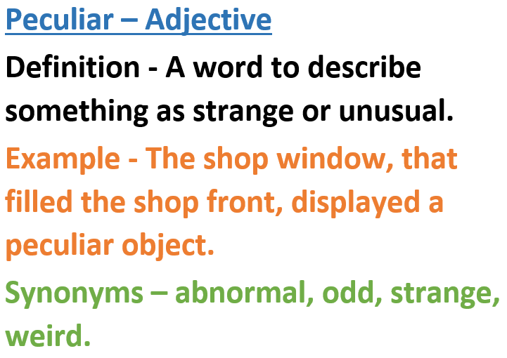
New Vocabulary for our Journey
For each journey, children will be introduced to new words. These words should be relevant to the work being produced within the English learning journey. These can be derived from the ‘excellence model’ or from your class text. Vocabulary should be displayed in classrooms (as follows) and should include the definition of the word, what type of word class it is and an example of the word within a sentence (related to the stimulus). Where possible, the example sentences should be created using the skills being taught for the learning journey. So, if the skill being taught is fronted adverbials, the example (some, not all) sentences should include fronted adverbials.
These should be visible for all children and should include the word, word class, definition, an example of the word used in a sentence and synonyms for that word.
Working Walls
These are an extremely important part of the learning process as they provide children with a form of continuous provision they can keep referring to throughout the journey. These should detail the skills being taught, give explanations and model examples. These should be written clearly and placed where all children can see them, ensuring that they are big enough to see/be used. During the process, the working walls should be referred to regularly and often as a way of modelling their use. The children should see that you are using these as a form of continuous provision. These should remain on the walls for as long as the children need and should remain after a learning journey so children are reminded and encouraged to use these skills in other writing tasks/areas of the curriculum. Success criteria and planning formats should be placed on these walls also. In addition to the working wall, we have a writing celebration display wall to celebrate the progress of individuals throughout their learning journey in a year.
A working wall could be of the following format:
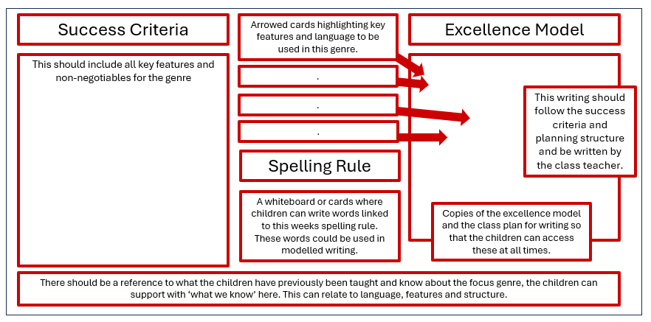
Cross-curricular links
Each term, there should be writing sessions linked to other areas of the curriculum to allow opportunity for children to use and apply their knowledge of taught genres.
Equal spread of coverage of genres
Genres of writing should be covered with an equal spread. Narrative is taught at the beginning of every term, followed by non-fiction and poetry. This is done so that children have the opportunity to apply skills equally to a range of writing as well being able develop technical, structural and vocabulary understanding. It also gives fixed points of comparison for each piece of writing. These genre overviews are done at the start of the year but are adapted when applied to other areas of the curriculum. We expect that genres are covered twice yearly across the curriculum.
There should be a range of genres covered in each year group, including fiction, non-fiction and poetry.
 | Non statutory text type/ genre guidance
Fiction | - Write stories set in places pupils  have been.  - Write stories that contain  mythical, legendary or historical characters or events.  - Write stories of adventure.  - Write stories of mystery and suspense.  - Write plays.  - Write stories, letters, scripts and fictional biographies inspired by reading across the curriculum. | Non-fiction | - Write persuasively  - Write recounts.  - Write instructions  - Write discussions/balanced arguments  - Write explanations.  - Write non-chronological reports.  - Write journalistic reports  - Write formal letters | Poetry | - Learn by heart and perform a significant poem.  - Write haiku.  - Write cinquain.  - Write poems that convey an  image (simile, word play,  rhyme and metaphor).
-Teachers clearly establish the purposes and audiences for writing at the start of the process of each ‘learning journey’ or unit of work.
-They make teaching objectives explicit to pupils so they know why they are studying a particular text or text type, the kind of writing activities they will need to undertake and the nature of proposed outcome, which is real and purposeful.
-The learning journey should be made clear to the children, who are fully involved in the process and clear about the outcome they are working towards.
-In Key Stage Two, pupils experience writing in different forms for a variety of audiences.
-They write for different purposes and are taught to plan, draft, proof read, improve and present their writing on paper and on screen, and to discuss and evaluate their own writing and that of others.
There is an emphasis on using real models for writing, e.g. newspaper reports, advertisements, websites. The links between reading and writing in fiction and non-fiction are to be made explicit. Pupils use their knowledge of texts they have studied to construct their own writing and have greater control over organisation, language features, vocabulary and spelling.
Edit and improve process using annotations and footnote system
Children will independently and/or collaboratively read back through their own writing. Whilst doing this, they will look for errors in punctuation, spelling and grammar and text mark this in purple pen. Once they have done this, they will then use a footnote system in order to improve/add sentences or sections to their work. Corrections or edits where one word is being changed/added should be done in the margin. If there is a punctuation mark being added should be done in the body of the text. Anything beyond this where children are changing or adding a whole sentence or a paragraph, this should be included as a footnote. Ensure that pupils understand that during this process they should think about all aspects of writing they can improve, not just skills within that learning journey. This is so that children focus on what can be improved holistically.
Non-negotiables
For each year group, there is a set of non-negotiables that all pupils must have mastered by the end of the year. This involves them using these tools independently and develop the ability to apply these in other areas of the curriculum. It is important that pupils understand the purpose of these tools and how they impact the reader and develop the text type. These would be useful to refer to when thinking about the skills coverage for each learning journey.
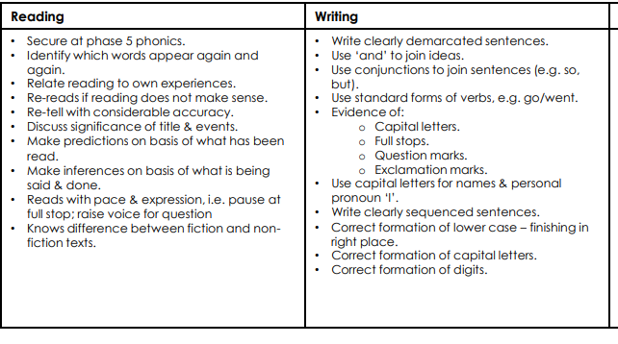
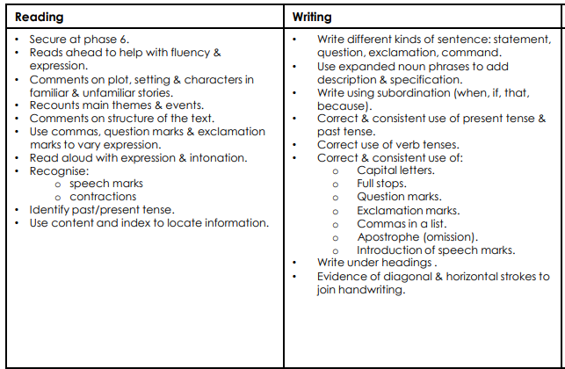
Year 1 Year 2

Year 3 | Year 4 | Year 5 | Year 6
- Use capital letters, full stops, question marks, exclamation marks and commas for lists.  - use conjunctions, adverbs and prepositions, mostly accurately, to inform time, place or cause  - Use conjunctions (when, so, before, after, while, because).  - Use adverbs (e.g. then, next, soon).  - Use prepositions (e.g. before, after, during, in, because of).  - Use nouns and noun phrases, modified by adjectives and other nouns to add detail, experimenting with adjectives to create impact.  - Correctly use verbs in 1st, 2nd and 3rd person.  - Use perfect form of verbs to mark relationships of time and cause.  - Use punctuation mostly accurately, including some use of inverted commas to indicate direct speech.  - Group ideas into basic paragraphs.  - Write under headings and sub-headings.  - Write with increasing legibility, consistency and fluency.  - Use ‘a’ or ‘an’ before a word starting with a vowel or consonant. | - Vary sentence structure, using different openers. Use sentences of different forms including some sentence structures with more than one clause  - Use past and present tense correctly and consistently  - Use some cohesive devices e.g. co-ordinating and subordinating conjunctions, adverbs and prepositions (to express time and cause) and nouns and pronouns (for clarity and to avoid repetition).  - Use adjectival phrases (e.g. biting cold wind).  - Use appropriate choice of noun or pronoun.  - Use fronted adverbials and use a comma after fronted adverbial (e.g. Later that day, I heard bad news.).  - Use apostrophe for singular and plural possession.  - Use commas to mark clauses.  - Use inverted commas and other punctuation to punctuate direct speech.  - Use paragraphs to organised ideas around a theme.  - Use connecting adverbs to link paragraphs. | - Use apostrophes for contraction/possessive apostrophe with plural and singular nouns mostly correctly.  - Use inverted commas and other speech punctuation to indicate direct speech.  - Use commas to clarify meaning or avoid ambiguity.  - Add phrases to make sentences more precise and detailed.  - Use range of sentence openers – judging the impact or effect needed.  - Use pronouns to avoid repetition.  - Indicate degrees of possibility using adverbs (e.g. perhaps, surely) or modal verbs (e.g. might, should, will).  - Use the following to indicate parenthesis:  - Brackets  - Dashes  - Commas  - Link clauses in sentences using a range of subordinating and coordinating conjunctions.  - Use relative clauses beginning with who, which and that to add detail and description  - Use verb phrases to create subtle differences (e.g. she began to run).  - Consistently organize into paragraphs.  - Link ideas across paragraphs using adverbials of time (e.g. later), place (e.g. nearby) and number (e.g. secondly).  - Use fronted adverbials with commas to vary sentence structure | - Use subordinate clauses to write complex sentences.  - Use passive voice where appropriate.  - Use expanded noun phrases to convey complicated information concisely (e.g. The fact that it was raining meant the end of sports day).  - Use a sentence structure and layout matched to requirements of text type.  - Use semi-colon, colon or dash to mark the boundary between independent clauses.  - Use colon to introduce a list and semi colon within a list.  - Use correct punctuation of bullet points.  - Use hyphens to avoid ambiguity.  - Use full range of punctuation matched to requirements of text type.  - Use wide range of devices to build cohesion within and across paragraphs.  - Use paragraphs to signal change in time, scene, action, mood or person.

Writing Assessments
As part of our assessment and internal moderation, we will judge writing with a holistic view looking at a range of writing across the curriculum. Following the objectives as they are set out in the National Curriculum and the End of Year Expectations for each year group, teachers will make our assessments using the assessment frameworks placed in the children’s books. These are found in the children’s books.

Handwriting
See separate handwriting policy.
Phonics and spellings
Each day, children in EYFS and Year 1 will be taught Phonics following the Little Wandle, revised letters and sounds scheme. Year 2 will follow this scheme accessing the ‘Bridge to spelling’ unit of work. Children from Year3 upwards will be taught spelling rule/pattern based on the curriculum explicitly following the Twinkl scheme of work, they will then be expected to apply this rule in sentences based on the context of their learning. Common exception words for the corresponding year groups will be sent home to practise, little and often if at all possible.
Reading
Reading in EYFS and Year 1 is taught in line with Little Wandle’s guided reading sessions. Children read the same book three times a week with a focus on decoding, comprehension and prosody. In Year 2 and beyond, our reading sessions focus on children’s fluency and comprehension skills, using VIPERS to support. Reading sessions will be completed using class text and other short complete texts and will provide opportunities for improving talk, fluency, comprehension skills, understanding grammar in context and building knowledge of authors’ particular choices. Children will also have the opportunity to respond with opinion and evidence.
Opportunity should be taken to present questions to children in a format similar to formal assessments, however the purpose is to make confident readers, debaters, writers and enable them to find evidence confidently for their responses and opinions. These sessions are vital so therefore should take one of the 5 English sessions a week.
Speaking and Listening
As well as being a fundamental part of the writing process, regular opportunity is provided for children to develop their speaking and listening skills through drama and role play, debate, discission or the sharing of work. We positively encourage children to listen to others’ thoughts and ideas with intent and then share their own with confidence.

