Dean Gibson Catholic Primary School
Sparrows Class Curriculum Overview
2023-2024
 | Autumn Term |  |  |  | Spring Term |  |  |  | Summer Term
English
Year 1 | 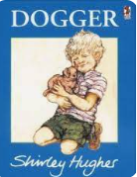 |  | 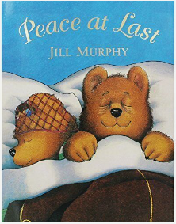  Also, a recount from a vet visit. |  | Science (Seasonal Changes)  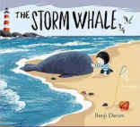 |  |  | History – Transport over time  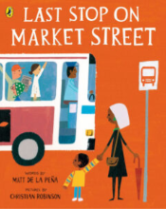 | Traditional tales  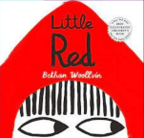 | Geography - There you are  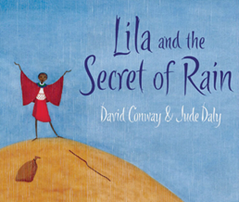
 | Genres
 | Narrative |  | Letter  Poetry  Recount |  | Narrative – sentence construction  Postcards  Non-chronological reports about whales. |  |  | Discussion/balanced argument focusing on finding beauty all around us.  Poetry | Narrative  Newspaper  Diary | Poetry  Instructions
Maths
Year 1 | Number  -Place Value  (within 10)  Number  -Addition & Subtraction  (within 10) |  | Number  -Addition & Subtraction  (within 10)  Geometry  Shape |  | Number  -Place value  (within 20)  Number  -Addition & Subtraction  (within 20) |  |  | Number  -Place value  (within 50)  Measurement  Length and height  Measurement  Mass and volume | Number  Multiplication and division  Number  Fractions  Geometry  Position and direction | Number  Place value (within 100)  Measurement  Money  Measurement  Time
RE
Year 1 | Creation and Covenant |  | Prophecy and Promise |  | Galilee to Jerusalem |  | Desert to Garden |  | Ends of the Earth |  | Dialogue and Encounter
Science
Year 1 | Humans | Animals |  | Seasonal changes |  | Materials |  |  | Plants |  | Consolidation
Art
Year 1 | I am an artist |  |  | Paper Sculpture |  |  |  |  | Natural World
Music
Year 1 | My musical heartbeat | Dance sing and play |  | Exploring sounds |  | Learning to listen |  |  | Having fun with improvisation |  | Let’s perform together
Geography
Year 1 | Here I am |  | Where we are |  | There you are
History
Year 1 | My Family History |  | History of Transport |  | Homes Through Time
Computing
Year 1 | Computing systems and networks – technology around us | Creating media – digital painting | Programming – moving a robot | Data and information – grouping data | Creating media – digital writing | Programming animations
PE
Year 1 | Gymnastics / Dance |  | Ball skills / Cricket |  | Athletics / Multi sports
Design Technology
Year 1 | Sliders and Levers |  | Wheels and axles |  | Free Standing Structure
PSHE
(HRSE and Online Safety)
Year 1 | Life to the Full  Me, My Body, My Health  Emotional Well-Being  Life Cycles  Project Evolve  Self Image and Identity  Online Relationships |  | Life to the Full  Personal Relationships  Keeping Safe  Project Evolve  Online Reputation  Online Bullying |  | Life to the Full  Living in the Wider World  Project Evolve  Managing Information Online  Health, Well-Being and Lifestyle

