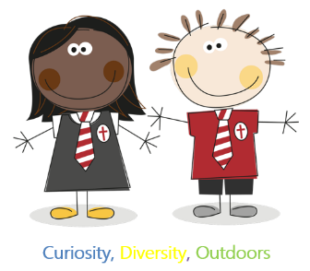
Dean Gibson Catholic Primary School
Finches Class Curriculum Overview
2023-2024
 | Autumn Term |  |  |  | Spring Term |  |  |  | Summer Term
English
Year 2 and 3 | 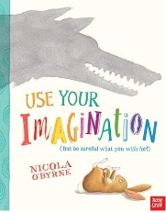  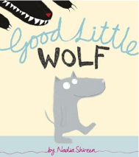  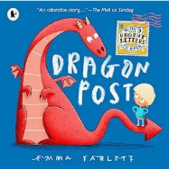 |  | 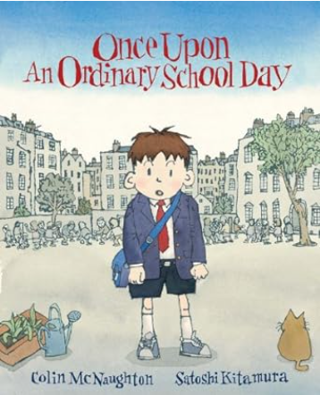 |  | 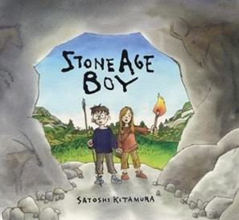  History – Prehistoric Britain  Science Plants:  Best children's books - Growing Plants Topic (booksfortopics.com) |  |  | Geography – Hot and Cold Deserts.  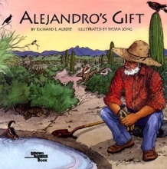  Science- Living Things and their habitats  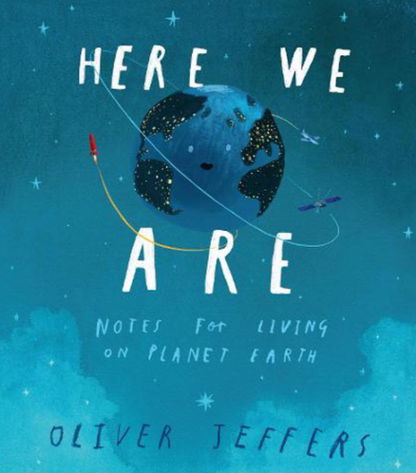 | 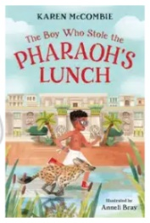  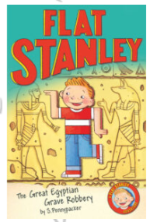  History – Ancient Egypt  Science - Light  Best children's books - Light and Dark Topic (booksfortopics.com) | 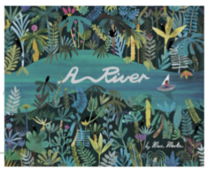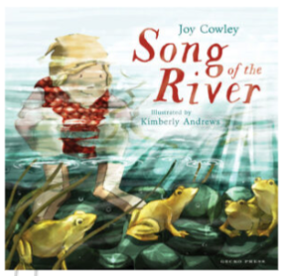
 | Genres
 | Narrative  Letters/postcards |  | Narrative  Explanations  Poetry |  | Narrative  non-chronological reports, |  |  | discussion/balanced argument.  recounts  Poetry | Narrative  Instructions  journalist report , | persuasive writing, Poetry
Maths
Year 2 and 3 | Number  -Place Value  (within 100) Y2  Number  -Place Value  (within 1000) Y3  Number  -Addition & Subtraction  (within 100 inc Money) Y2  Number  -Addition & Subtraction  (within 1000 inc Money) Y3 |  | Number  -Addition & Subtraction  (within 100 inc Money) Y2  Number  -Addition & Subtraction  (within 1000 inc Money) Y3  Number  -Multiplication Y2&3 |  | Number  -Division Y2&3  Statistics Y2&3  Measurement  -Length&  Height Y2&3 |  |  | Geometry  -Shape, Position&  Direction Y2  Number  -Fractions Y2&3  Geometry  -Shape& Perimeter Y3 | Measurement  -Time Y2&3  Problem Solving Y2&3 | Measurement  -Mass, Capacity&  Temperature Y2  Measurement  -Mass & Capacity Y3  Investigations Y2&3
RE
Year 2 and 3 | Creation and Covenant |  | Prophecy and Promise |  | Galilee to Jerusalem |  | Desert to Garden |  | Ends of the Earth |  | Dialogue and Encounter
Science
Year 2 and 3 | Rocks  Everyday Materials | Needs of Animals |  | Plant Life |  | Living Things and Habitats |  |  | Light |  | Solids Liquids and gases.
Art
Year 2 and Year 3 | Autumn Art |  |  | Colour and Tone |  |  |  |  | Painting Water
Music
Year 2 and Year 3 | Pulse rhythm and pitch | Playing in an orchestra |  | Inventing a musical story |  | Recognising different sounds |  |  | Exploring improvisation |  | Our big concert
Geography
Year 2 and Year 3 | The United Kingdom |  | Hot and Cold Deserts |  | Rivers Seas and Oceans
History
Year 2 and Year 3 | Travel and Transport |  | Prehistoric Britain |  | Ancient Egypt
Computing
Year 2 and Year 3 | Computing systems and networks – IT around us | Creating media – digital photography | Programming – robot algorithms | Data and information – pictograms | Creating media – digital music | Programming quizzes
PE
Year 2 and Year 3 | Dance / Gymnastics / Swimming |  | Cricket/Netball / Swimming /Yoga |  | Cricket / Athletics / Football /Yoga
Design Technology
Year 2 and Year 3 | Moving Vehicles (Wheels and axels)  (Sci - Forces and Motion) |  | Preparing Fruit and Veg  (Sci Food and Digestion) |  | 2D and 3D products  (Sci - Properties of materials)
PSHE
(HRSE and Online Safety)
Year 2 and Year 3 | Life to the Full  Me, My Body, My Health  Emotional Well-Being  Life Cycles  Project Evolve  Self Image and Identity  Online Relationships |  | Life to the Full  Personal Relationships  Keeping Safe  Project Evolve  Online Reputation  Online Bullying |  | Life to the Full  Living in the Wider World  Project Evolve  Managing Information Online  Health, Well-Being and Lifestyle
Spanish
Year 3 | Meet and Greet  Sign of the Cross and Hail Mary | My Body  Christmas in Spain | Time to Eat | All about school Easter celebrations | My Town | Let’s Go!

