We are Artists
In Art and Design, when a child leaves Dean Gibson we would like them to…
become expressive and creative individuals who can confidently communicate throughout various artforms.
During their time at Dean Gibson, we want children to develop the confidence to experiment with a wide variety of techniques such as drawing, painting, printing and sculpting and develop their own personal style and experience a wide range of media. Pupils will also be able to describe, using visual language, the work of local and renowned artists and designers whilst taking inspiration from such people to create their own original masterpieces.
Throughout their time at school, pupils will treasure the same sketchbook from Reception to Year 6.
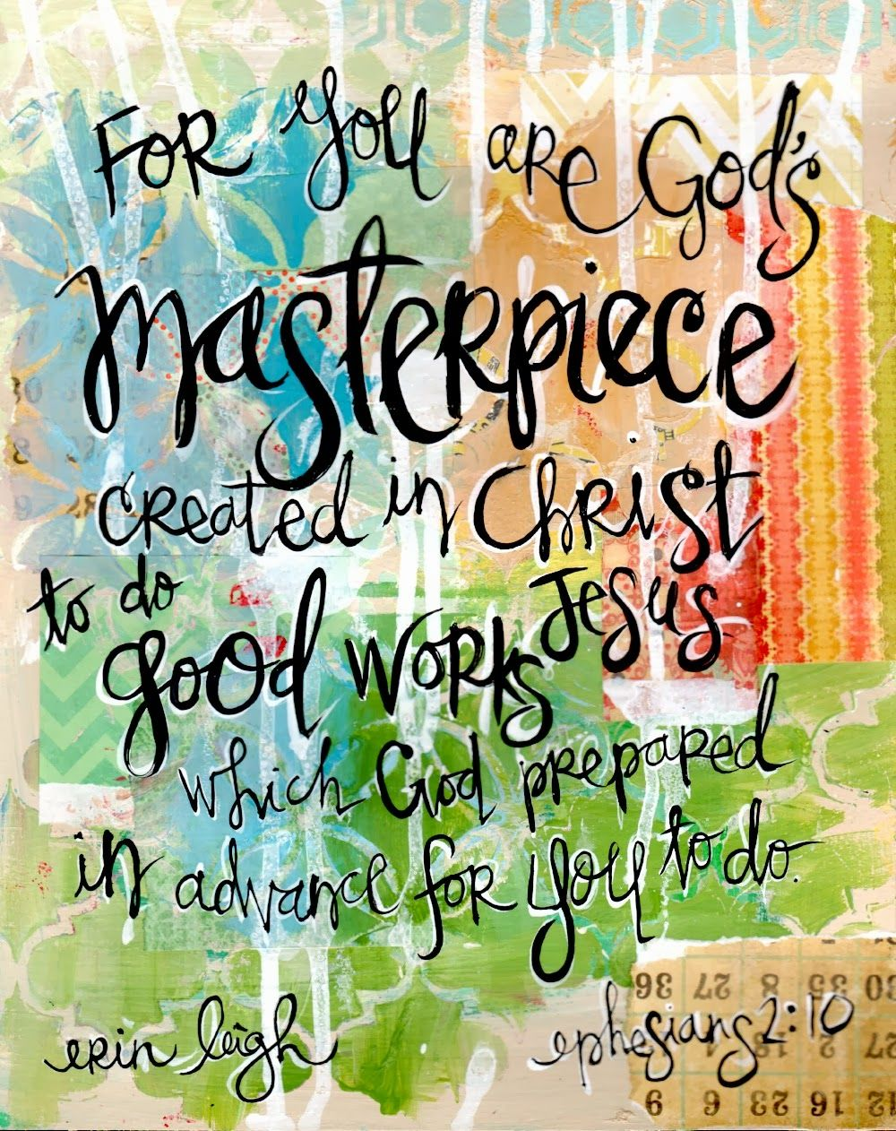

Enrichment
Artists | Examples of how we enrich the curriculum | Whole School
EYFS | - Outdoor days within the school grounds with some focus on Art and Design using natural materials.  - Art for church celebrations  - Art linked with national events and/or celebrations e,g, Remembrance Day. | Printfest  Tim Farron’s Christmas Card Competition  Nicky Smith Artist  Community projects e.g. supporting St. John’s Hospice  Lakeland Comic Arts Festival  International Week – celebrating art from other cultures  Celebrating national events e.g. Remembrance Day through art  Rag Tag Community Projects  Lakeland Arts
Jackson Pollock
Yayoi Kusama Piet Mondrian
Joan Miro
Andy Goldsworthy
Eric Carle
Georgia O’Keeffe
Year 1 | - Outdoor days within the school grounds with some focus on Art and Design using natural materials.  - Sculpture in the grounds  - Trips to exhibitions/workshops  - Sharing with KS2  - Art linked with national events and/or celebrations e,g, Remembrance Day.  - Art for church celebrations
Paul Klee
Piet Mondrian
Wassily Kandinsky
Charles McGee
Leonardo De Vinci
Claude Monet
Frances Hatch
Year 2 & 3 | - Outdoor days within the school grounds with some focus on Art and Design using natural materials.  - Sculpture in the grounds  - Trips to exhibitions/workshops  - Sharing with KS2  - Art linked with national events and/or celebrations e,g, Remembrance Day.  - Art for church celebrations
Zaha Hadid
The Boyle Family
Emily Haworth-Booth
Pablo Picasso
Katsushika Hokusai
David Hockney
Claude Monet

Year 3 & 4 | - Exhibition visits  - Art in the grounds  - Invite local artists including printmakers/textiles etc.  - Workshops  - Art for church celebrations  - Art linked with national events and/or celebrations e,g, Remembrance Day.  - Sharing of Art with KS1
Yayoi Kusama
Abel Rodriguez
Henri Rousseau
Henri Matisse
Pippa Goodhart
Joseph Cornell
Year 5 | - Exhibition visits  - Art in the grounds  - Invite local artists including printmakers/textiles etc.  - Workshops  - Art for church celebrations  - Art linked with national events and/or celebrations e,g, Remembrance Day.  - Sharing of Art with KS1
Raphael
Leonardo Da Vinci,
Michelangelo
Marjane Satrapi
Mel Tregonning
Richard Long,
Frida Kahlo
Lubaina Himid
Mark Heard,
Jackie Morris

Year 6 | - Outdoor days within the school grounds with some focus on Art and Design using natural materials.  - Sculpture in the grounds  - Trips to exhibitions/workshops  - Sharing with KS1  - Art linked with national events and/or celebrations e,g, Remembrance Day.  - Art for church celebrations  - Art linked with national events and/or celebrations e,g, Remembrance Day.
Ifeoma Anyaeji,
Serge Attukwei Clottey,
Veronika Richterova,
Katherine Harvey,
Camille Pissarro,
Stephen Wiltshire,
Kurt Switters,
Judith Kerr,
Yinka Shonibare,
Soia Boyce.

How Artists and Designers are taught in our school
This is how it works:
- Lesson provided through cross curricular or discrete lessons
- Clear progression of skills developed throughout school
- Progression of knowledge developed each year
- Children will have had the opportunity to showcase individual or collaborative work in the school and wider community
- Opportunities to work with artists from the community and beyond where possible
- Workshops and art days that bring topics to life and links with the wider curriculum

This is what adults do:
- Teachers use the United Learning scheme to ensure even coverage of skills.
- Teachers work collaboratively to support each other in the teaching of art, understanding and applying current developments in the subject, and providing direction for the subject in the school.
- Teachers show enthusiasm for the subject regardless of personal capabilities.
- Curriculum leader evaluates the strengths and development areas in the subject and indicate areas for further improvement.
- Create a positive learning environment to encourage discussion and personal opinion.
- Host after school art clubs.

This is how we support:
- We teach art to all children, whatever their ability, in accordance with the school curriculum policy of providing a broad and balanced education to all children.
- Teachers provide learning opportunities matched to the needs of children (including small group or 1:1 where needed)
- A range of equipment and resources so children can make progress
- Exposure to a wide range of artists and styles of art

This is how we challenge:
- We have high expectations and provide children the opportunity to develop their pieces.
- Additional activities to stretch learning or develop skills

This is how we ensure all children can access the curriculum:
- EAL and SEN children are introduced to vocabulary before the lesson
- Peer support
- Providing a variety of equipment that may support individuals

Impact
This is the impact of the teaching:

As a result of the delivery of our Art curriculum at Dean Gibson Primary School you would typically see confident and engaged children who talk about themselves as artists, craft makers, designers and architects. They will talk enthusiastically about the subject and reflect on their learning.

Children will be working in groups, pairs and independently demonstrating that they are self-motivated, resilient and able to make choices about how they express themselves.

Children can confidently refer to various media and techniques that they can use and will be able to explain the artistic process.

Children are able to talk about how contemporary and past artists have inspired them. Examples of their work will be evidenced in sketch books.

